Name :- Justin Ziv Patil

Register No :- 2347122

**Creating an Azure End-To-End Data Engineering Project For The Olympic Data Analytics**

Step 1 :- Login to your Azure portal

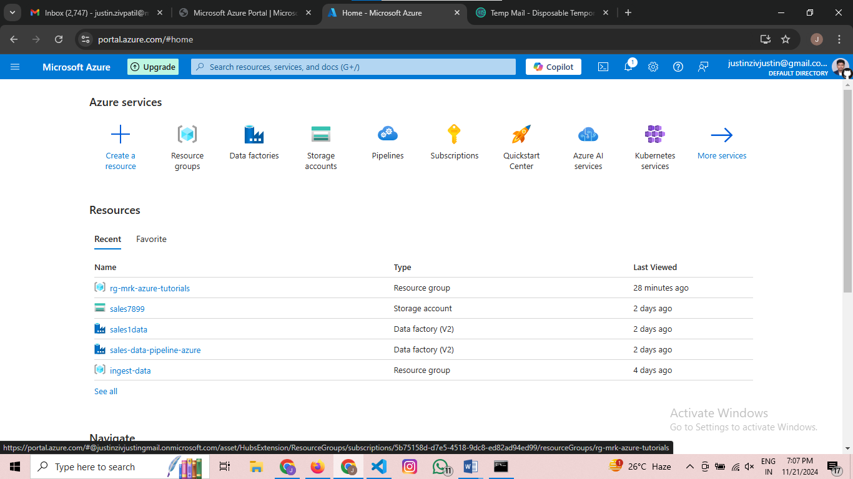

Step 2 :- Create a resource group based on the name convention

Since we are working based on the Tokyo Olympics I’ll name my resource group as Tokyo_Olympics

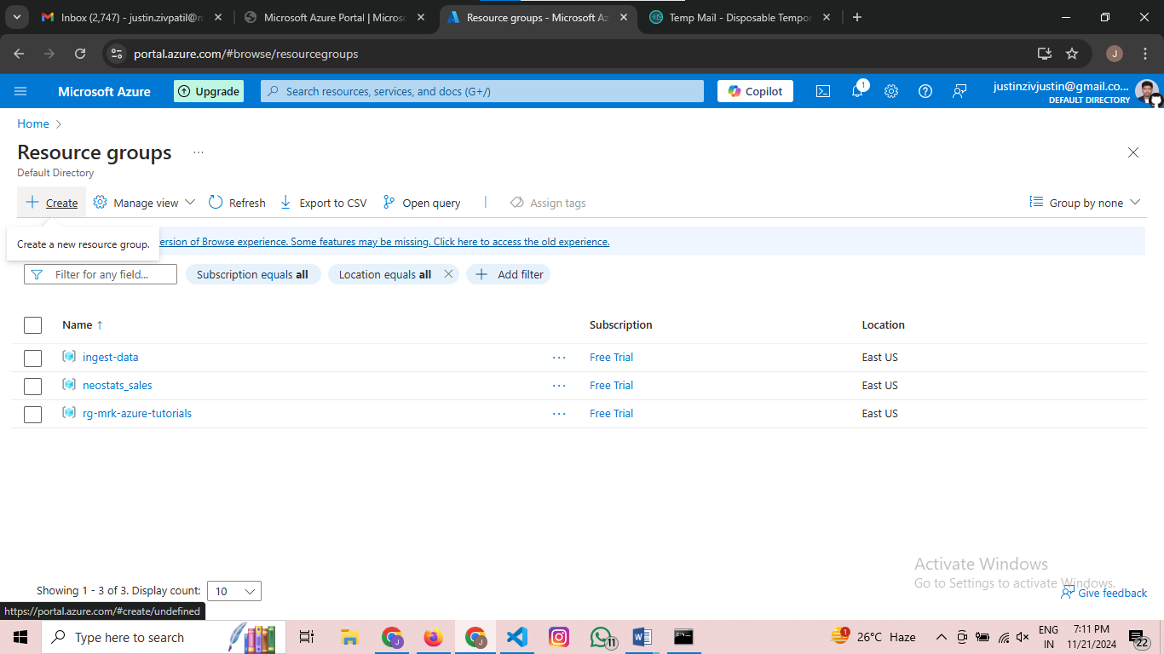

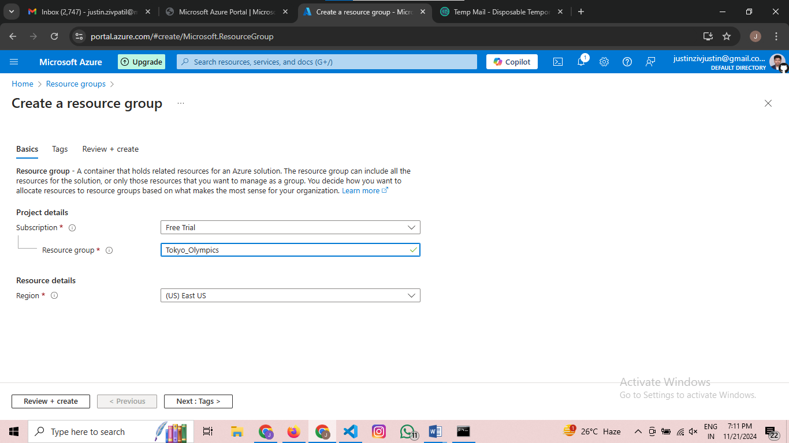

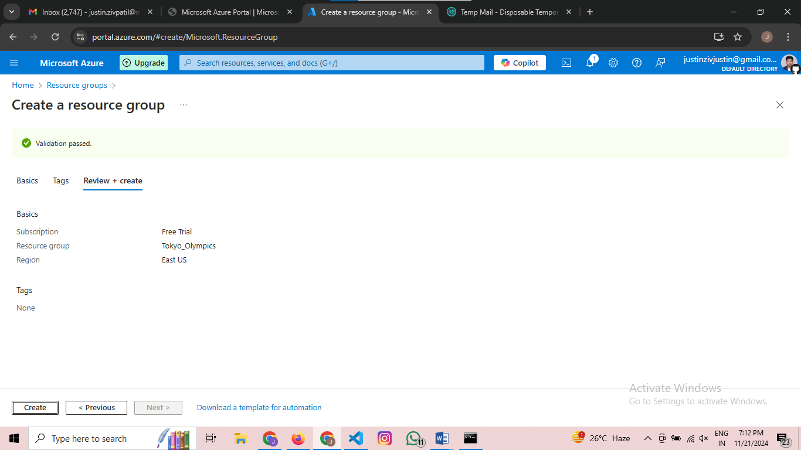

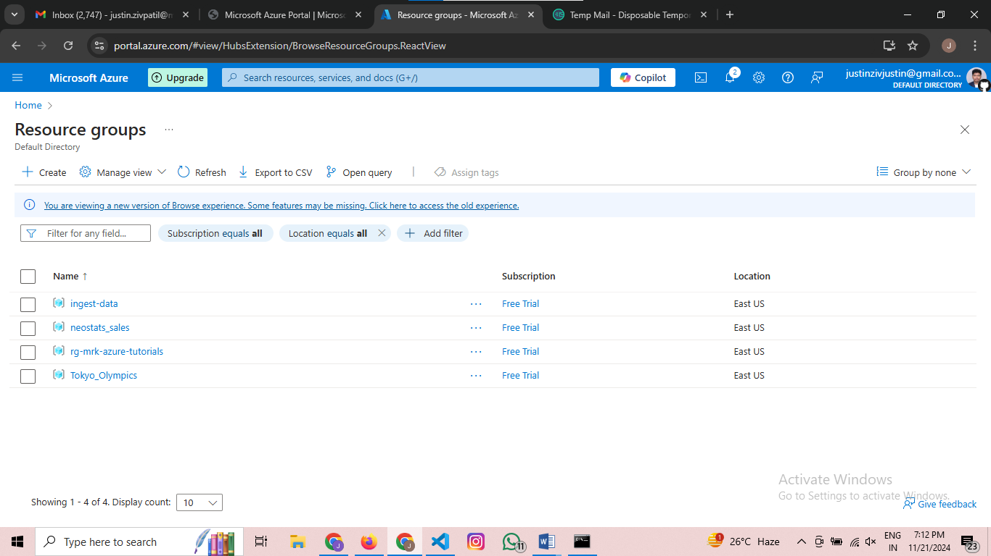

Sucessfully Created a Resource Group

Step 3 :- Creating a Storage Account

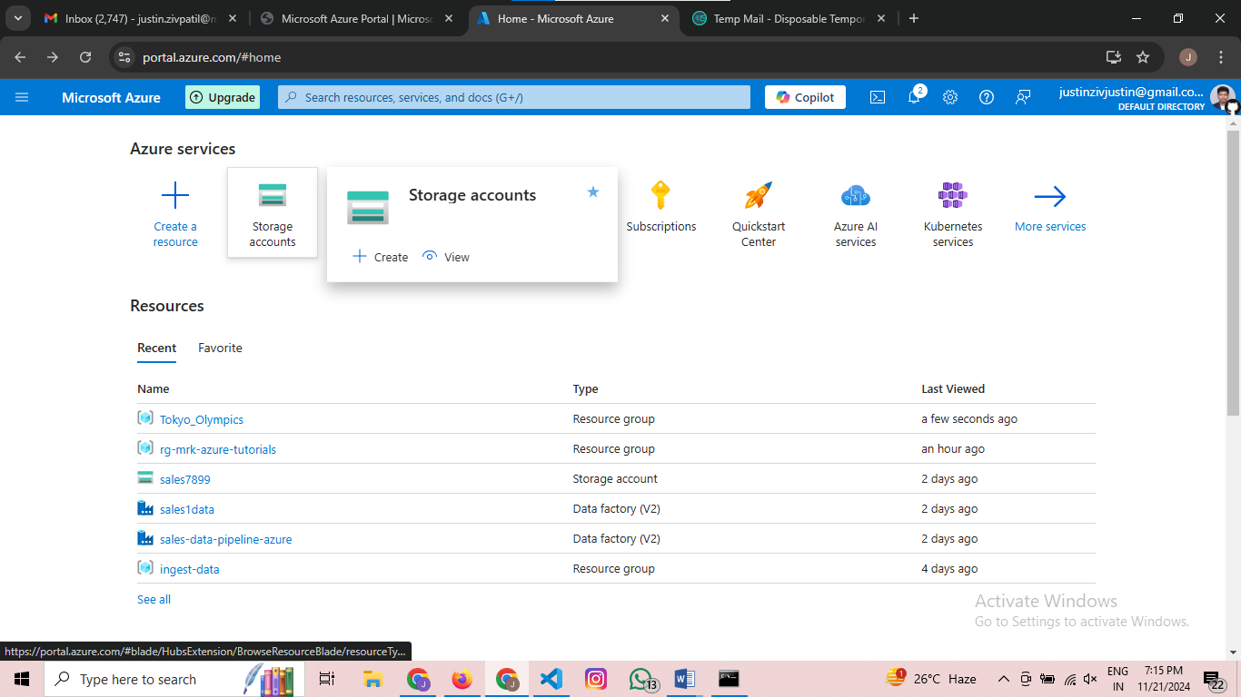

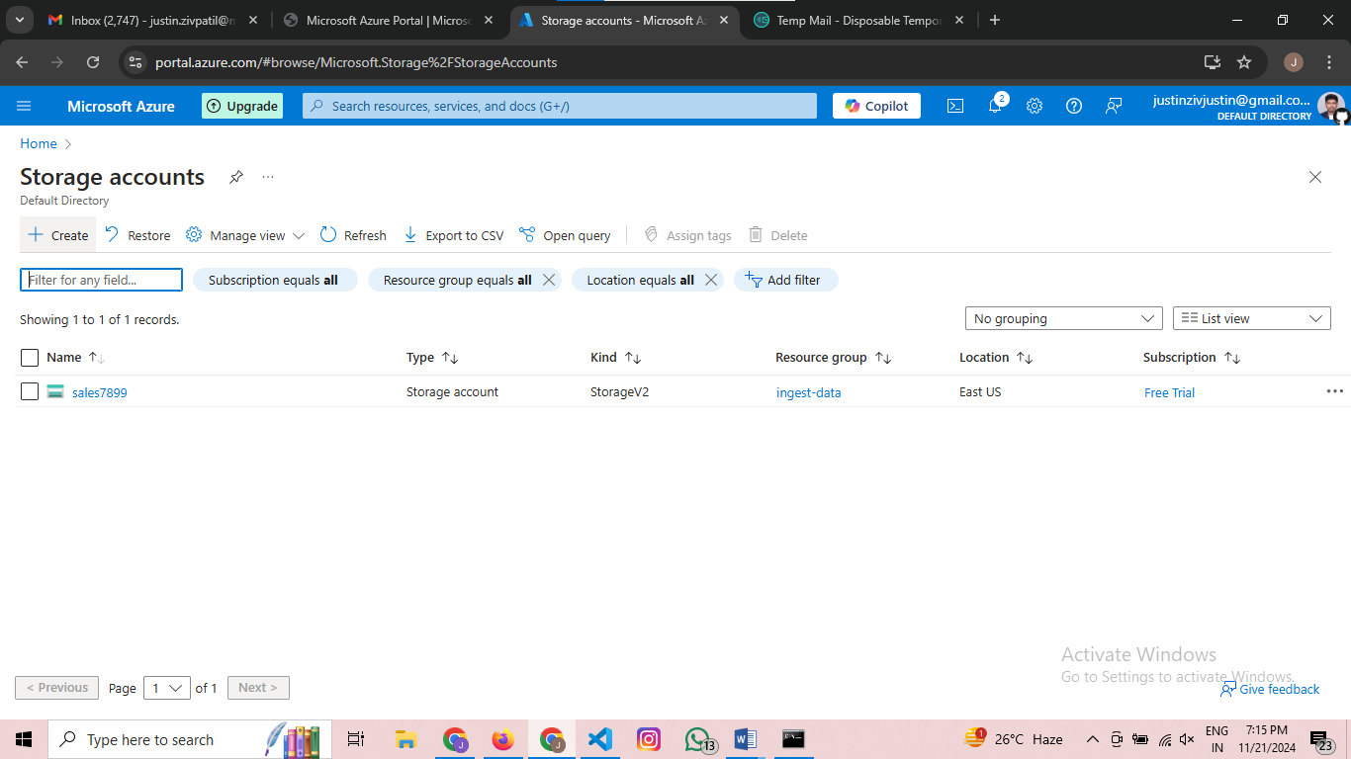

Make sure you select the same as I did

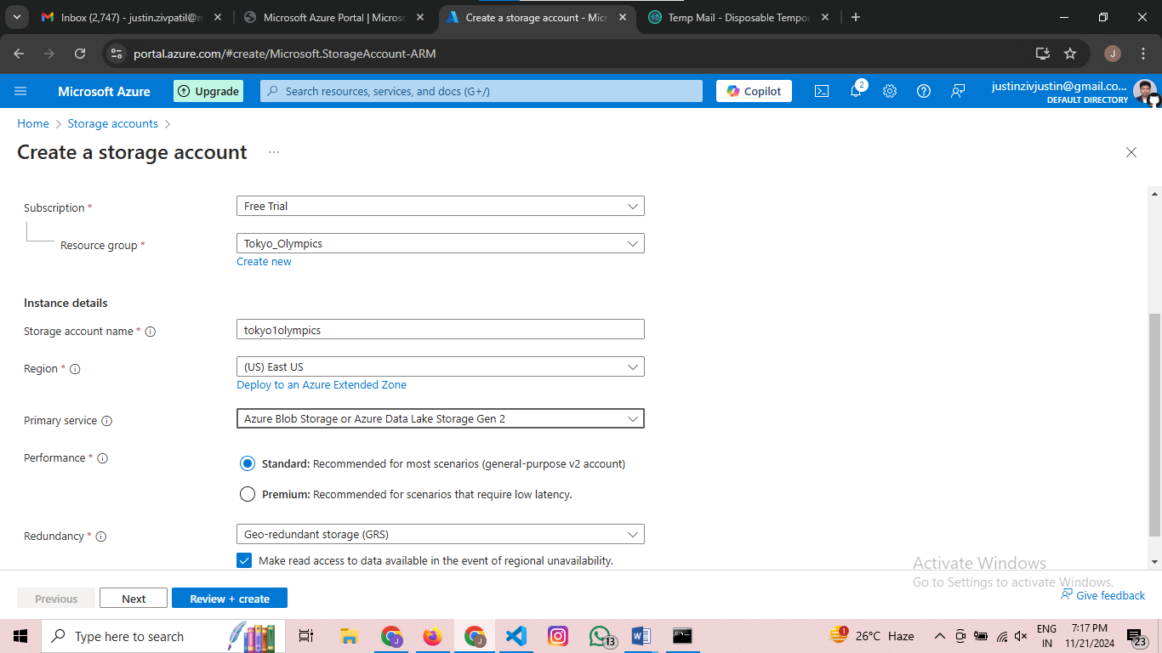

Enter create button

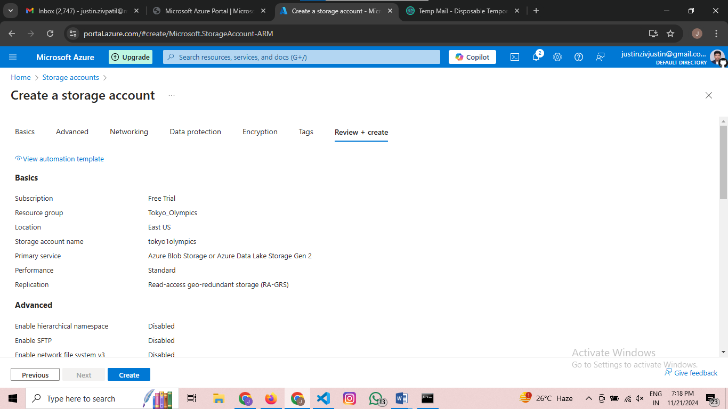

Wait for 2 to 3 minutes then after deployment is successful your page looks like this

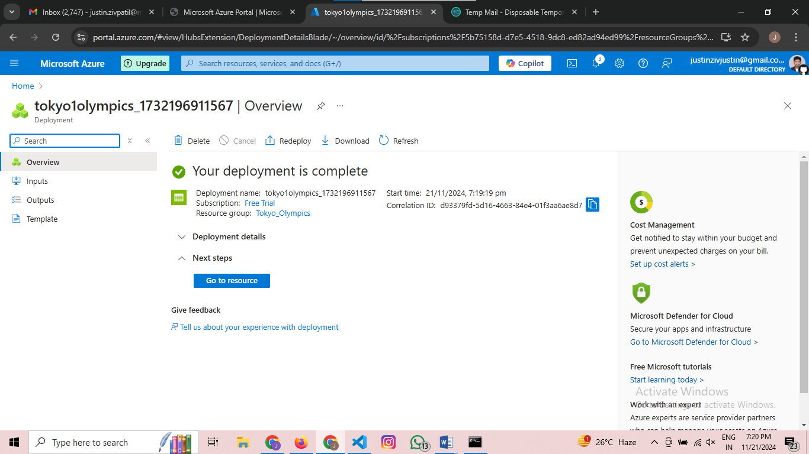

Then Go to resource then the page looks like below

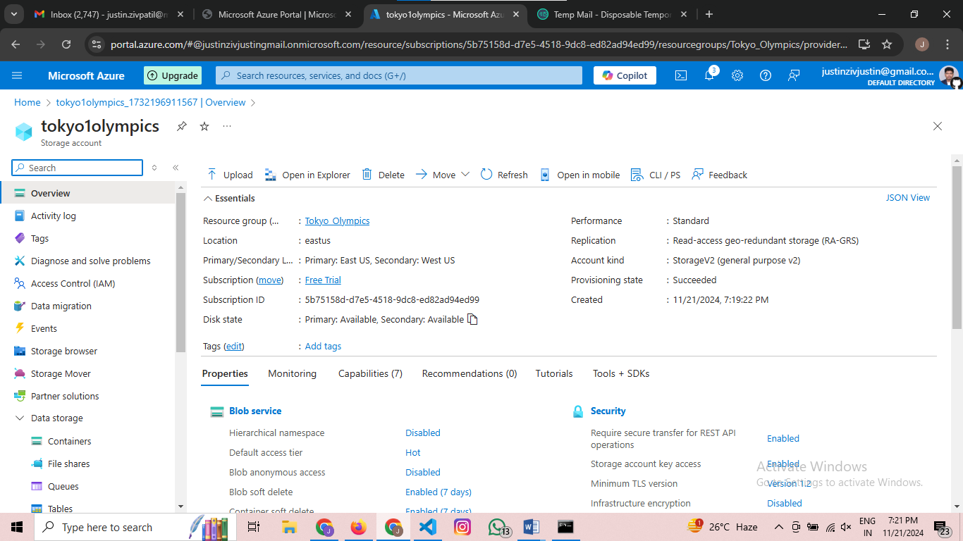

Step 4:- Creating a container and storing data or ingesting data to it

Go to the container in left portal

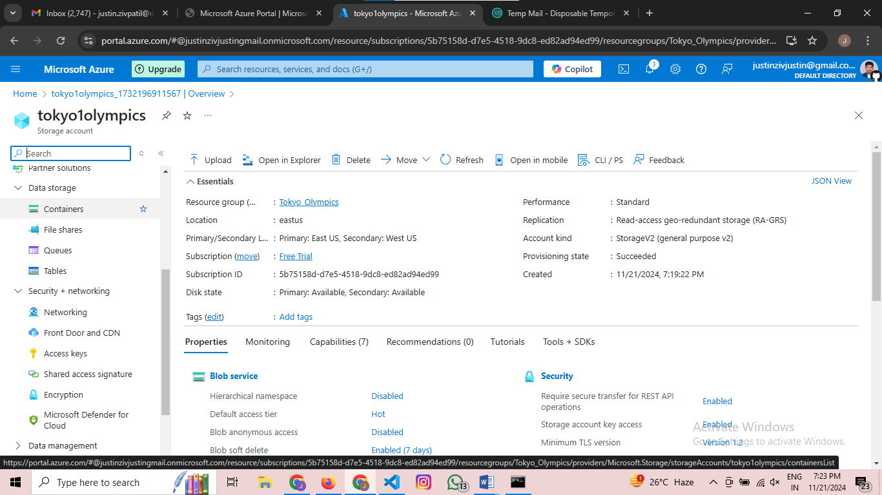

After pressing the portal the page looks like below  
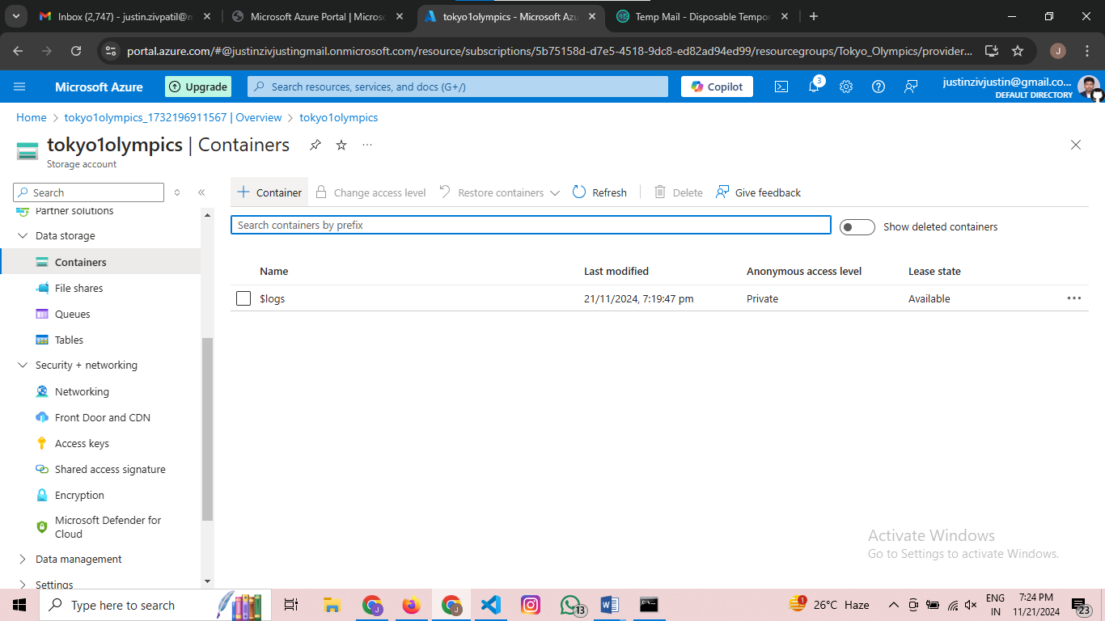

In the above page press on +container and you will see a page like below  
I am naming the dataset as tokyoolympicdata

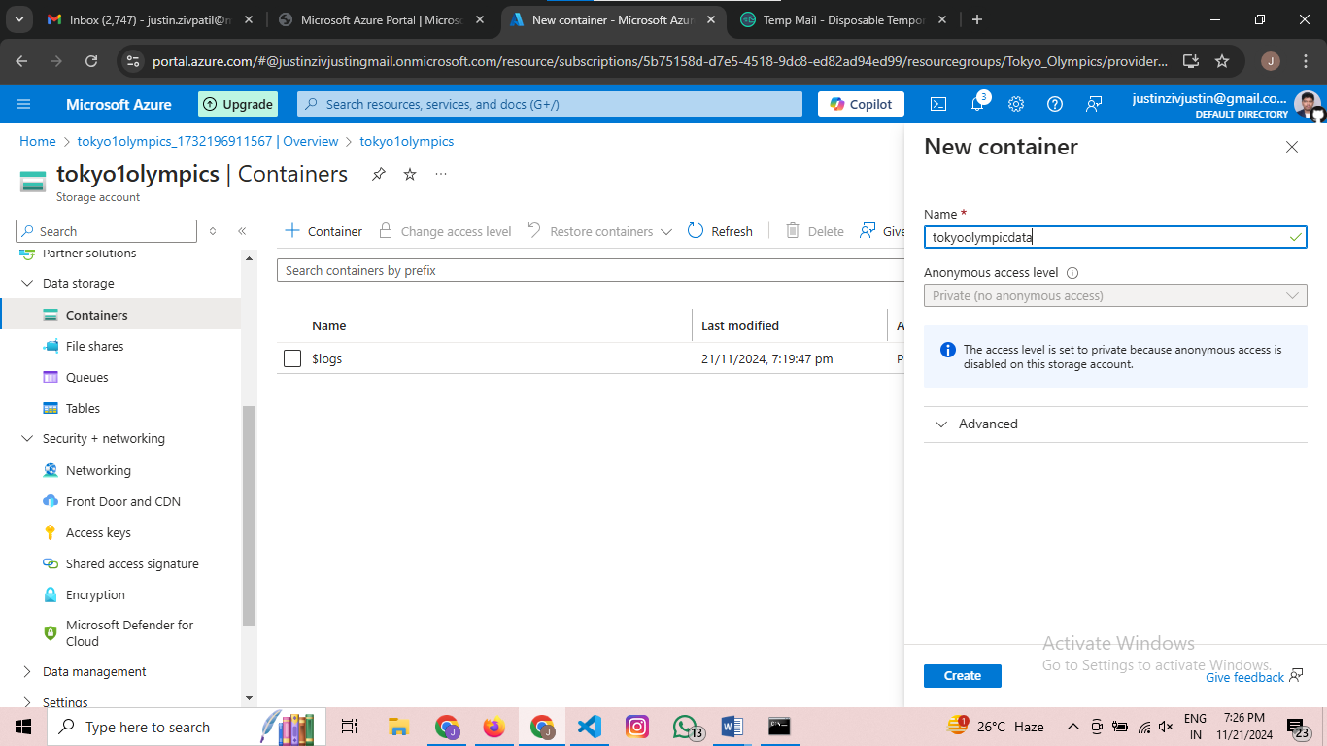

Press create button

After successfully created the storage account the page looks like below

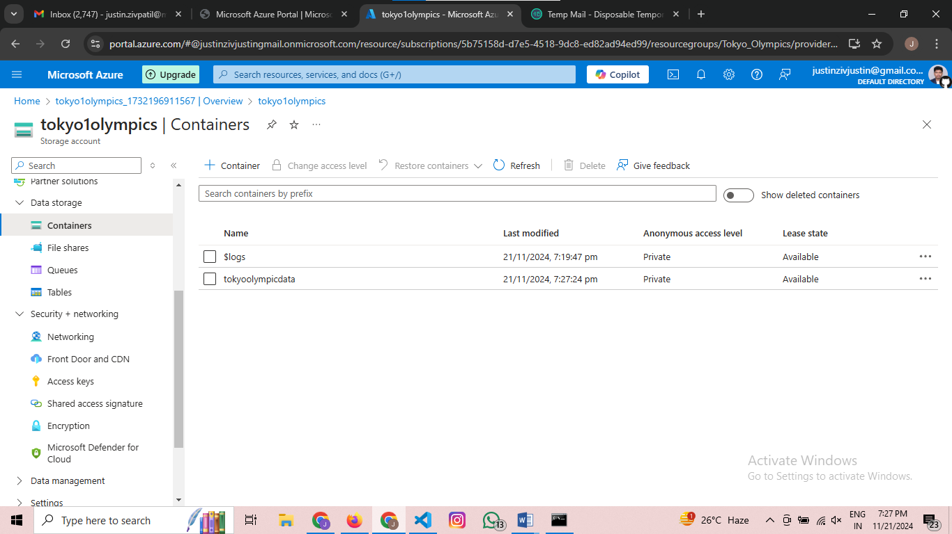

After creating press the account you created and the page looks like below

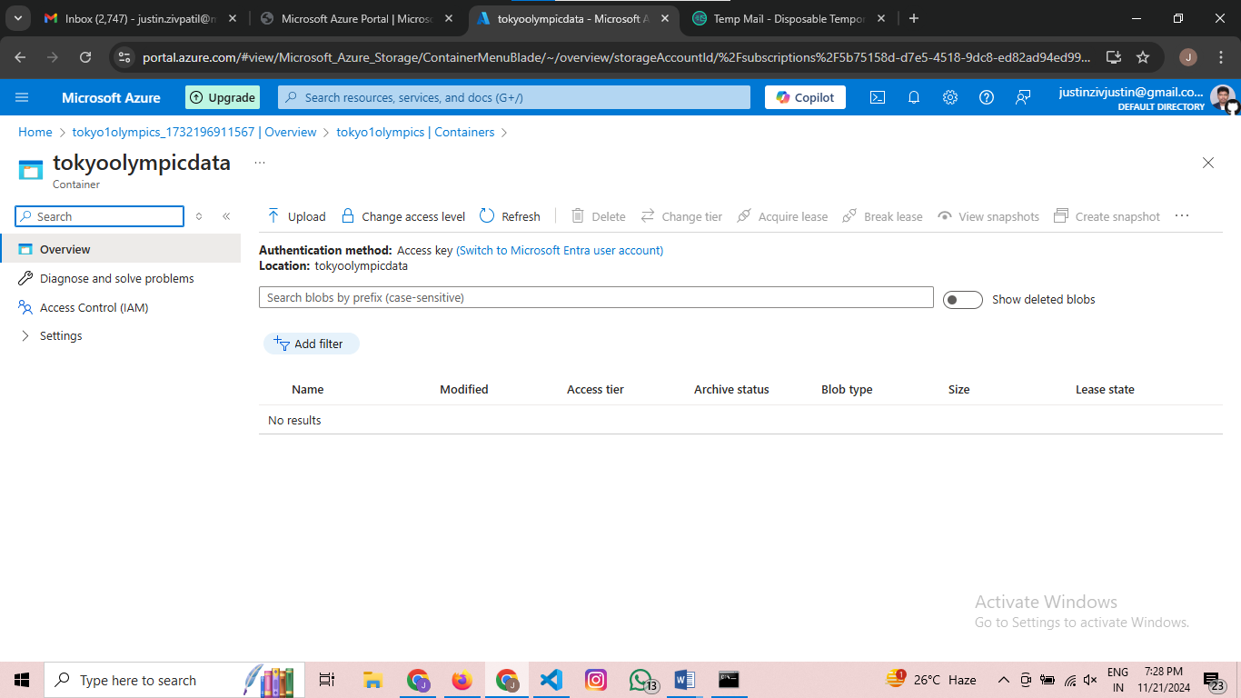

Step 5 :- Uploading a dataset

Press on the upload button then select the files which u need to upload then after selecting your page looks like below

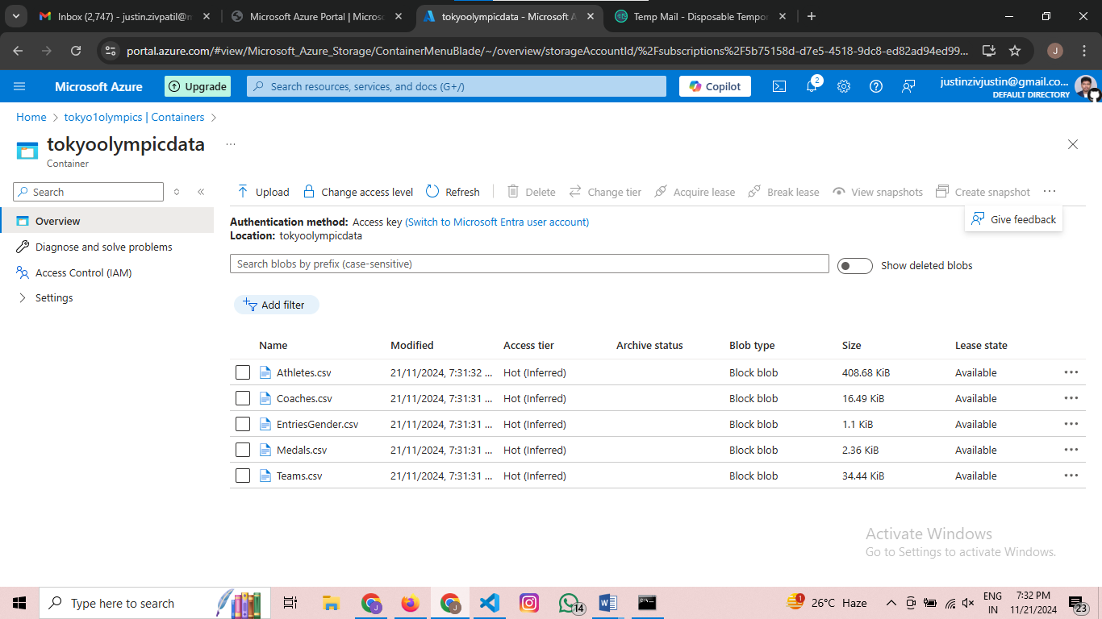

If you don’t see add directory option go to upload choose advanced and write the folder_name and upload the files  
In Here we need two folders for raw_data and transform_data

So in raw_data add the original files whereas in transformed_data just create a dummy_file later we will proceed with that

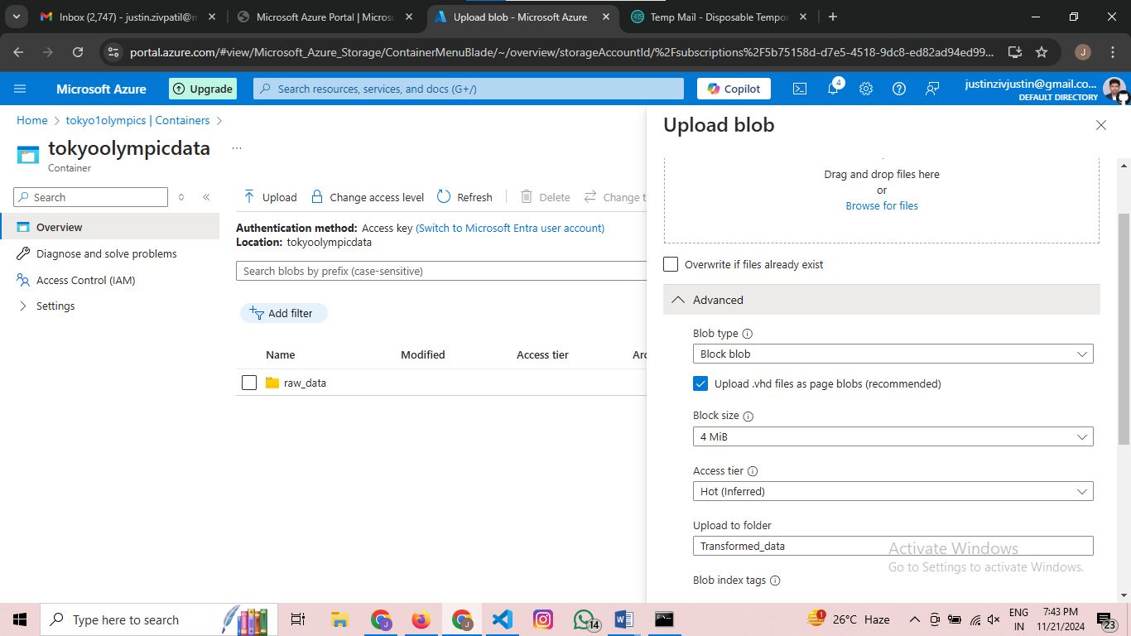

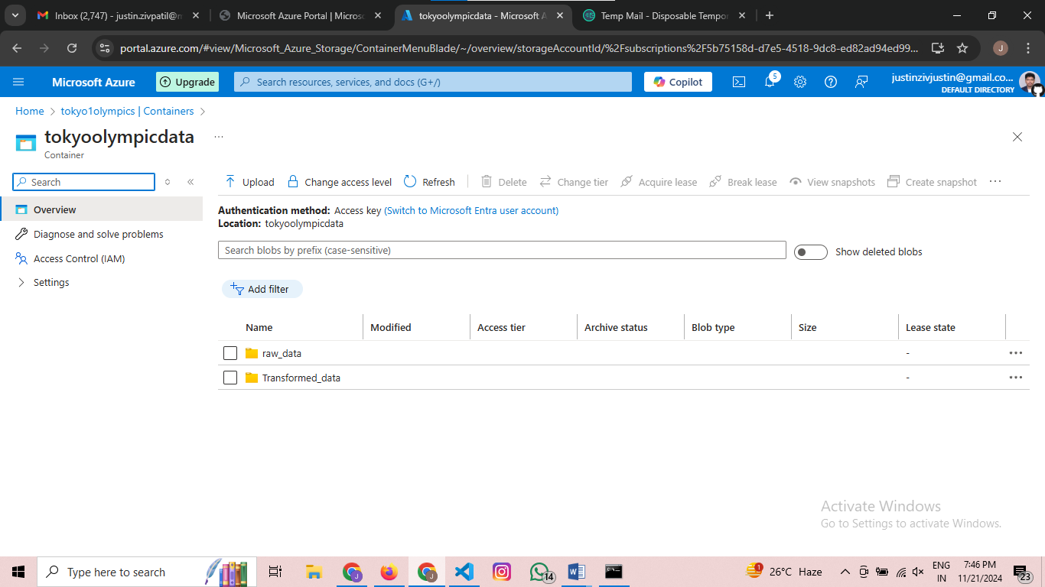

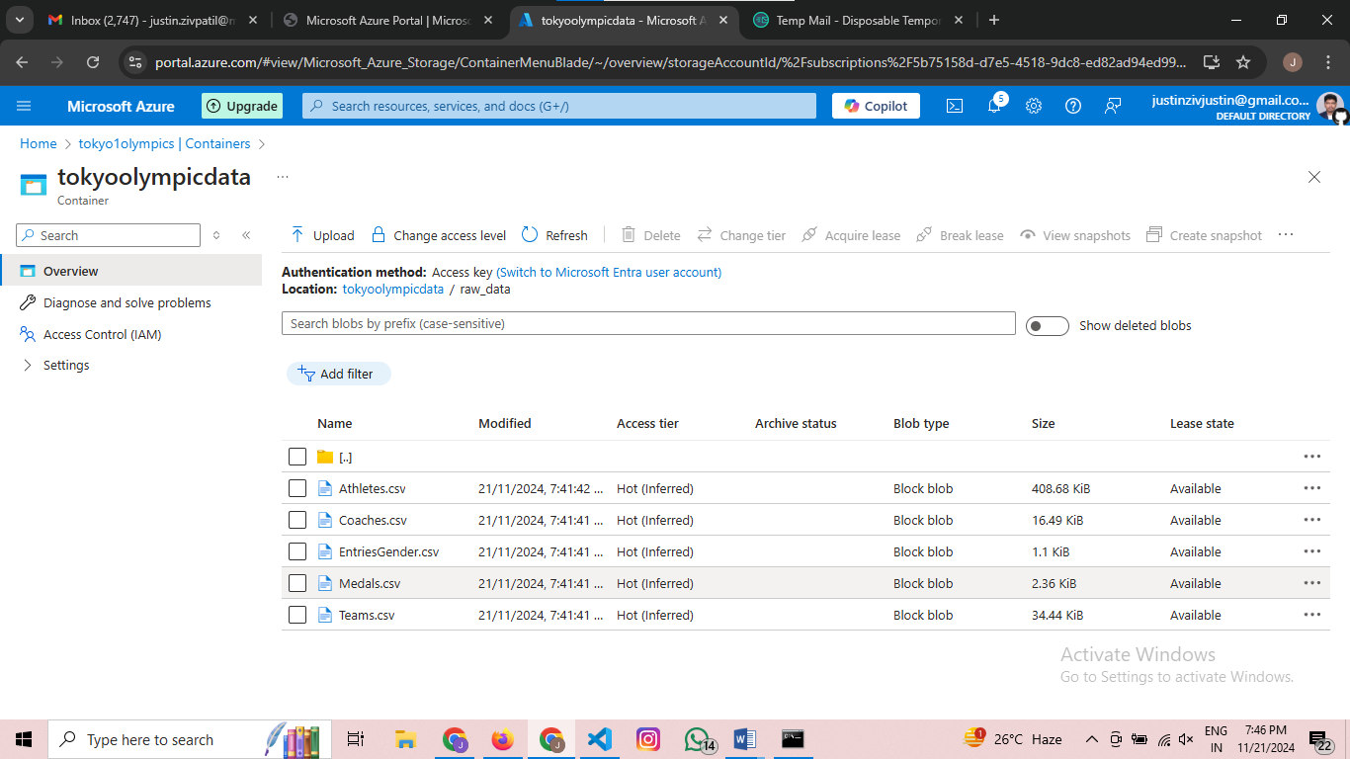

Step 6:- Create a Datafactory

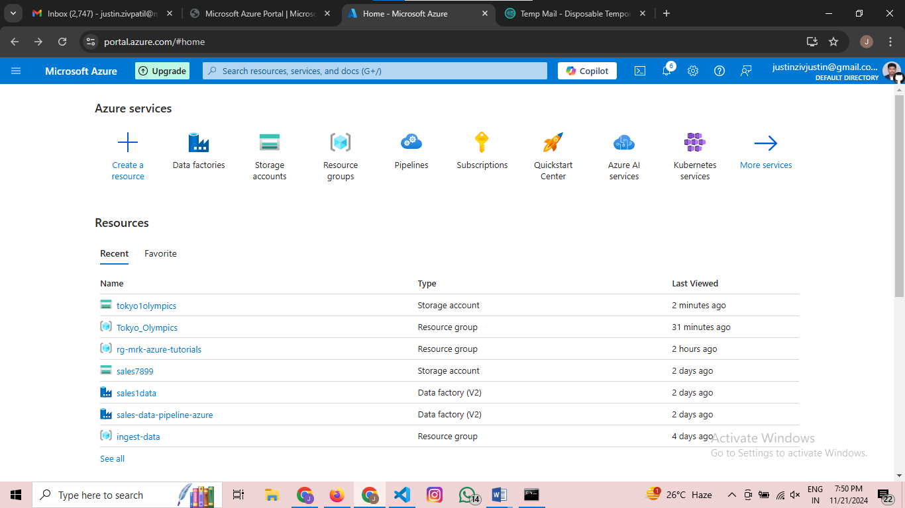

Press the data factories button

Then create a new data factory by pressing the +create button

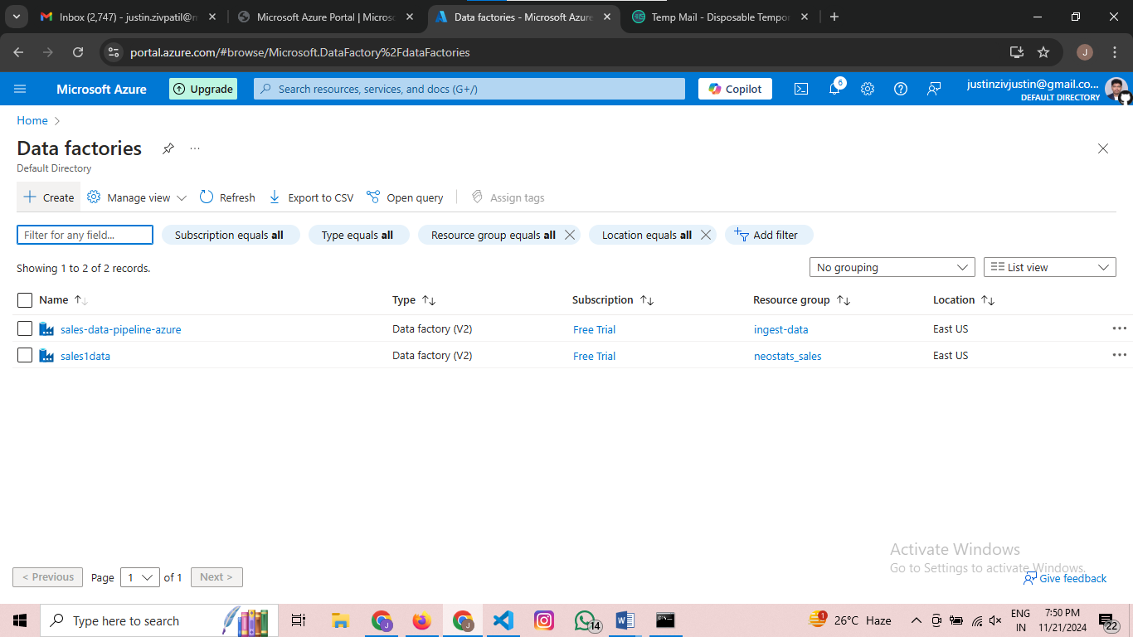

The page looks like this

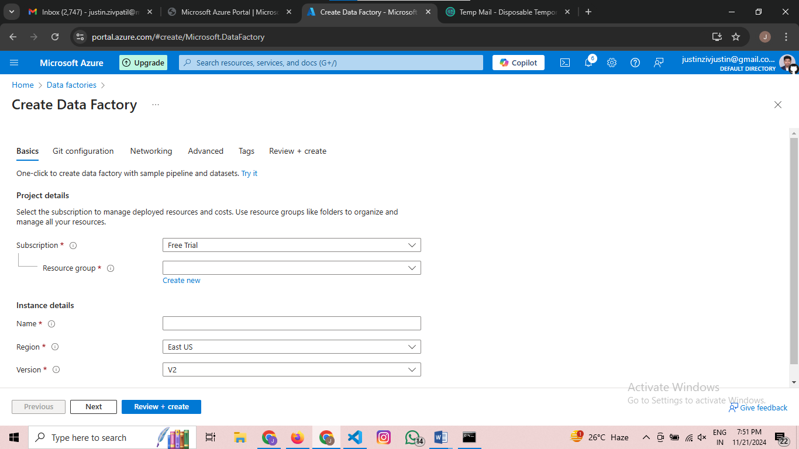

Now fill the following as follows

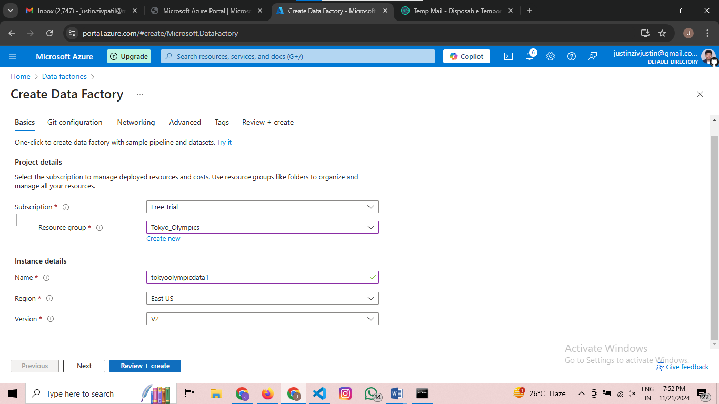

Press review+create then the folder looks like this

Then press Create

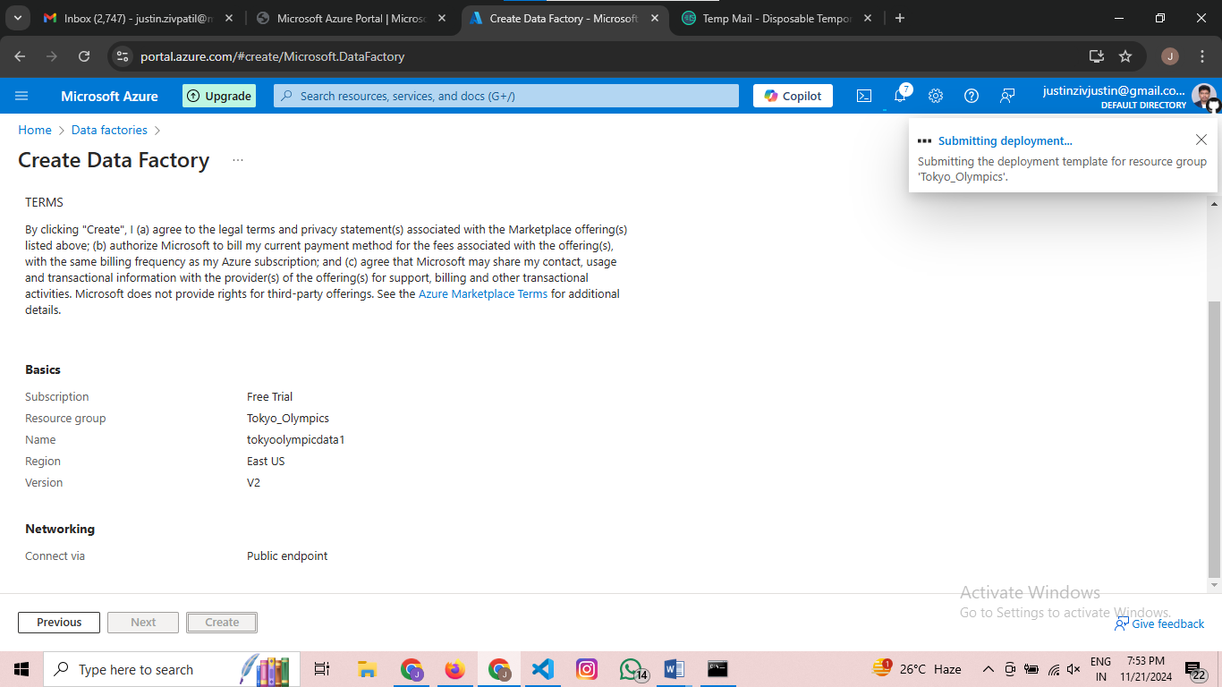

After creating successfully the page looks like below

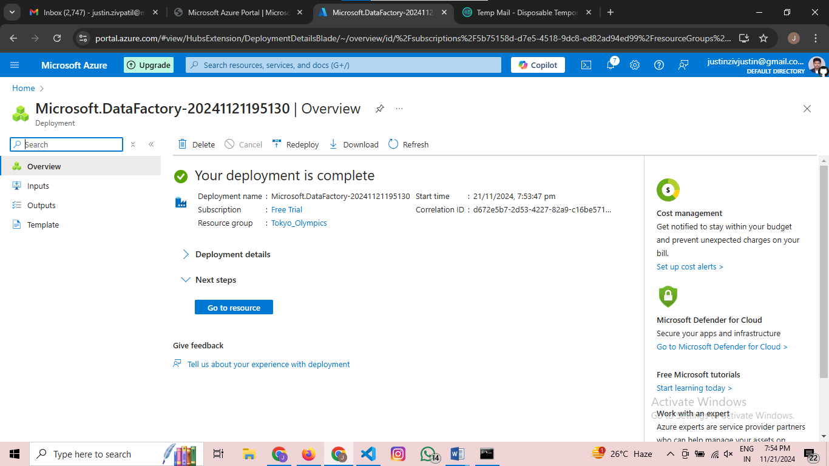

Then press go to resources

The page looks like this

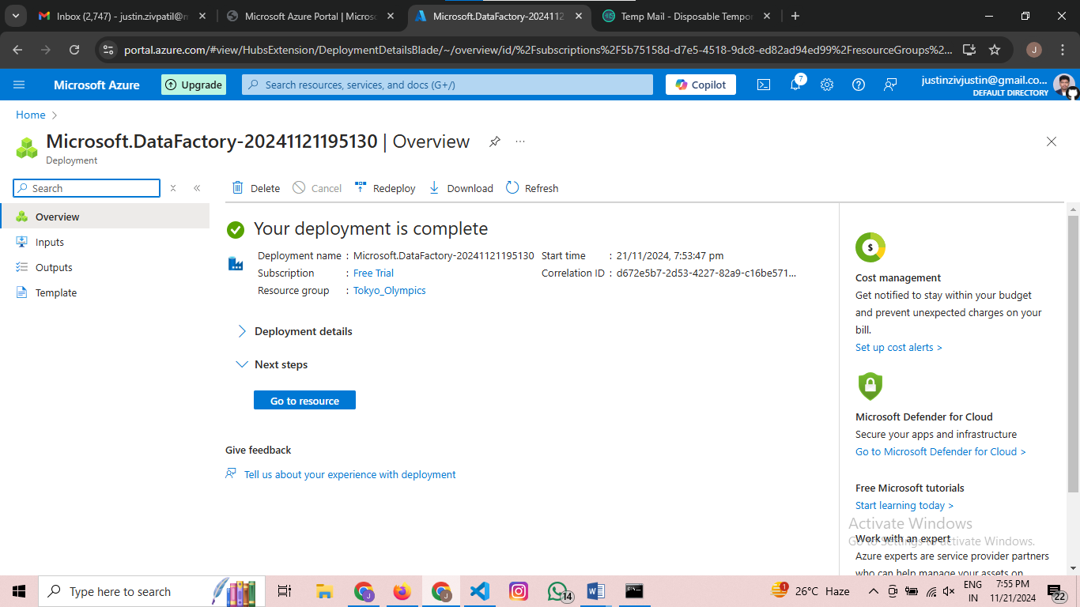

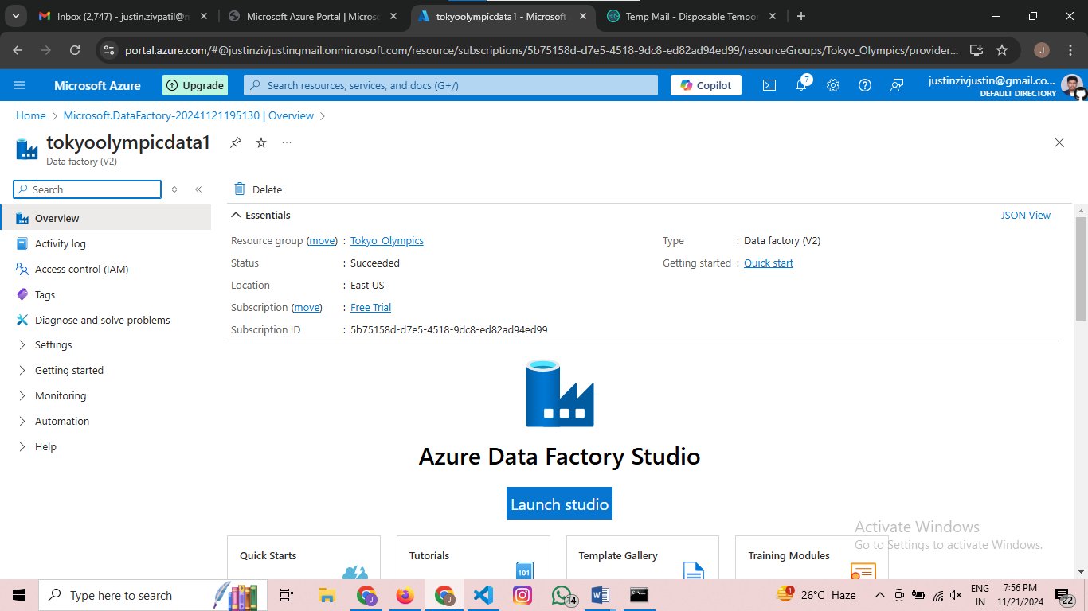

Press Launch Studio then then the page will look like this

Wait for 2 to 3 mins

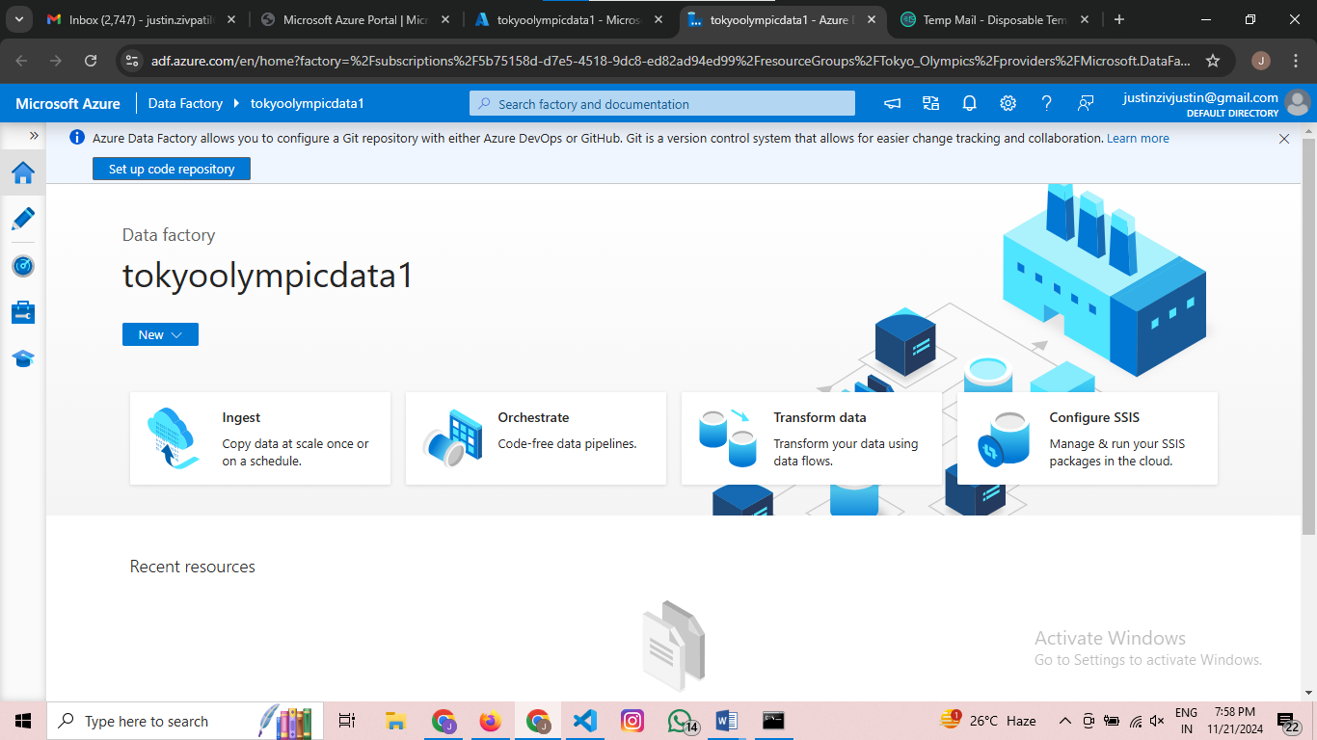

Step 7 :- Creating a pipeline

Go to author button or pencil symbol button

Your page looks like this

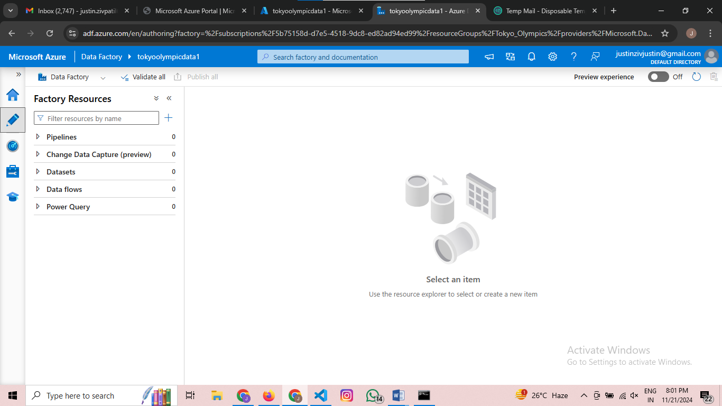

Press on + symbol

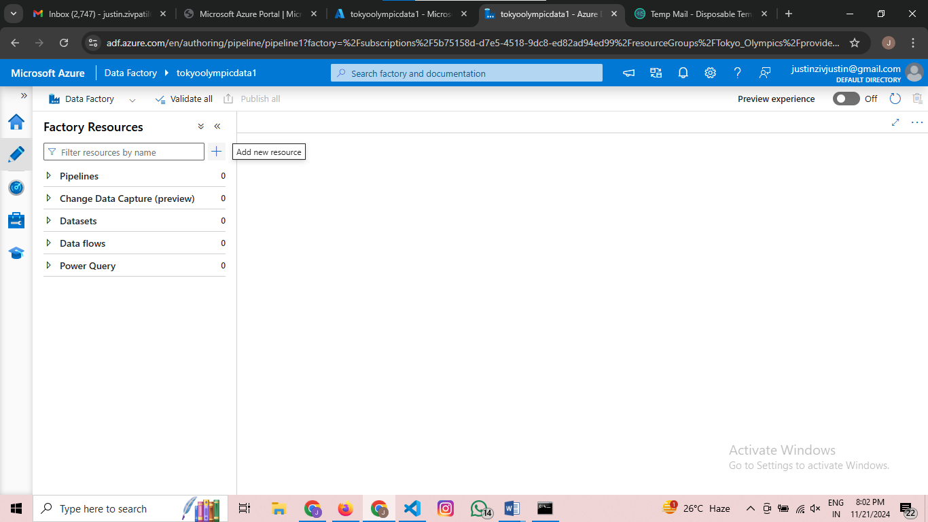

Choose pipeline 🡪 pipeline

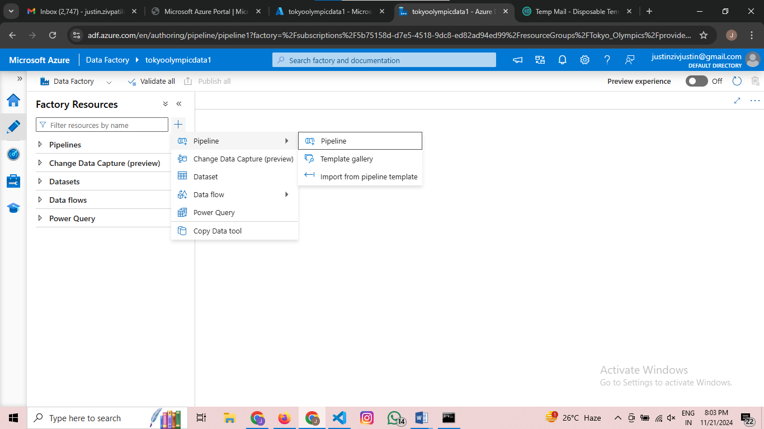

I have named the pipeline as data_ingestion just for name convention you can name it of your choice

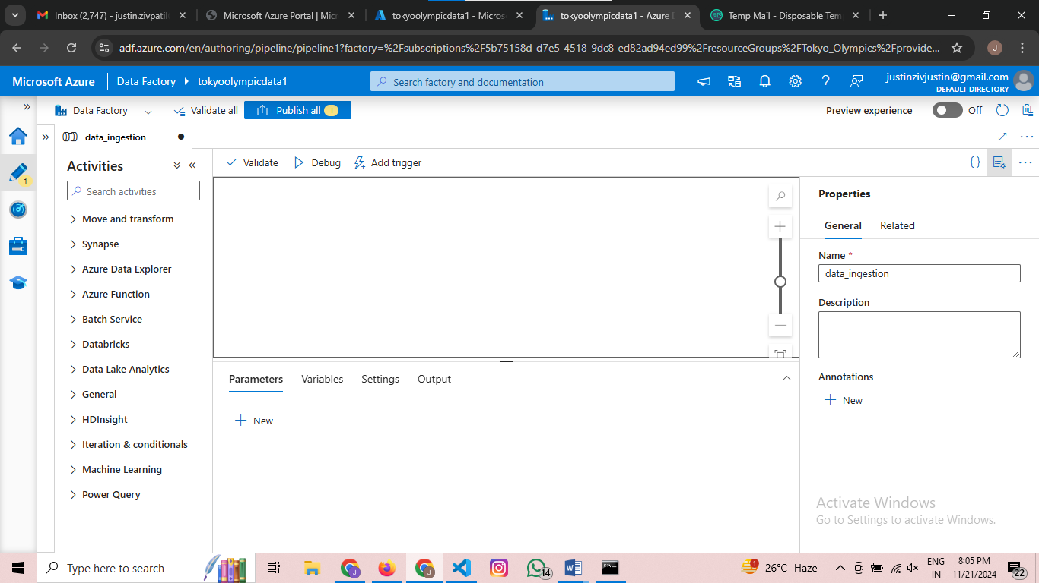

Search for copy data then the page looks like this

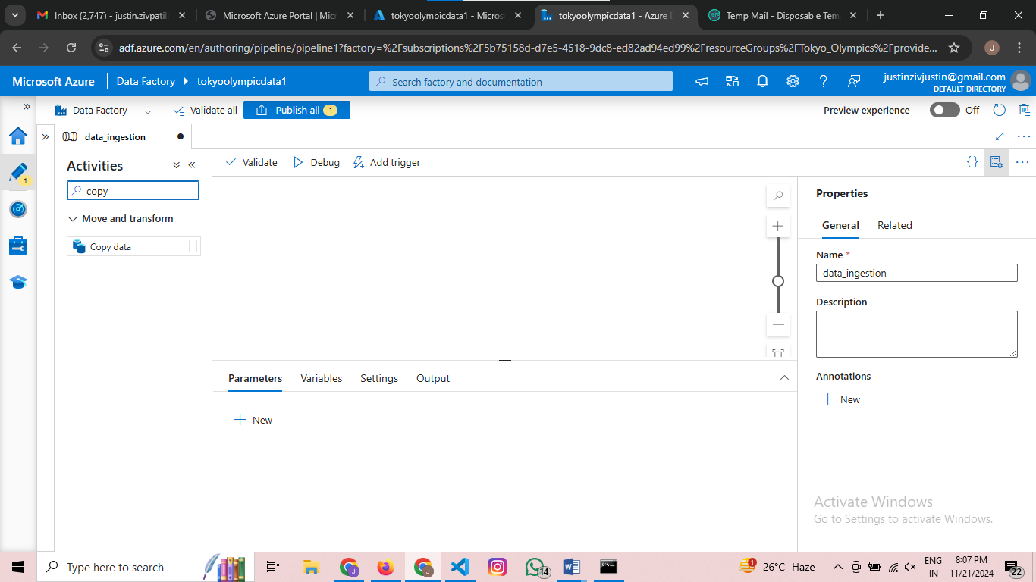

Now drag and drop the copy data then the page looks likes this

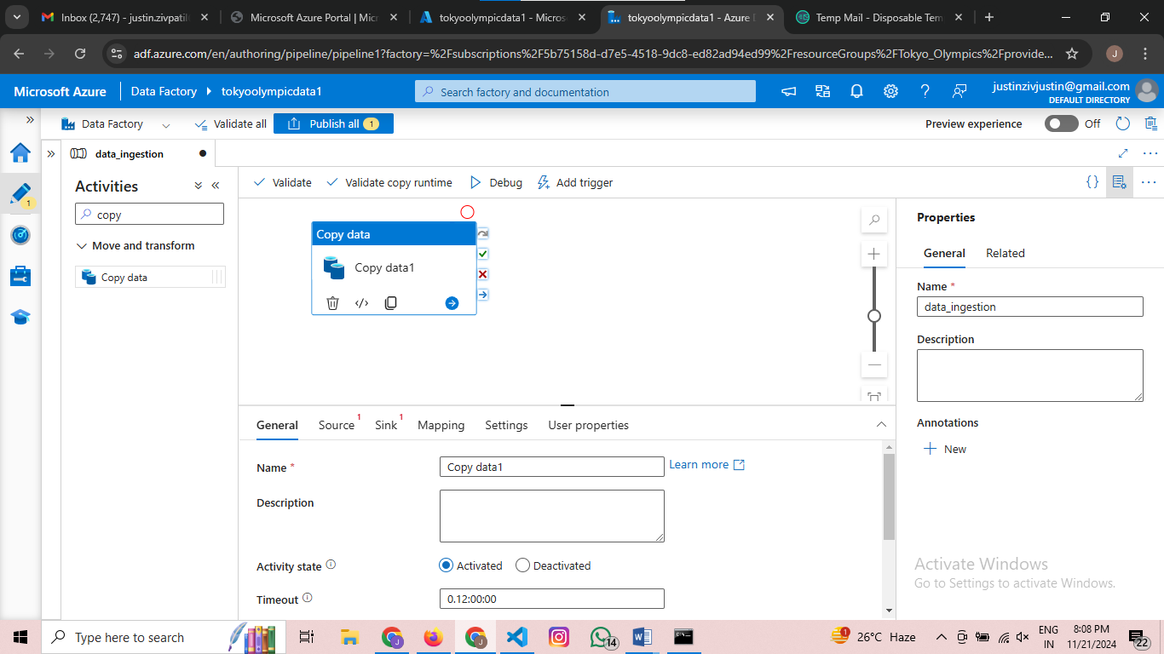

Then go to Source and page looks like this

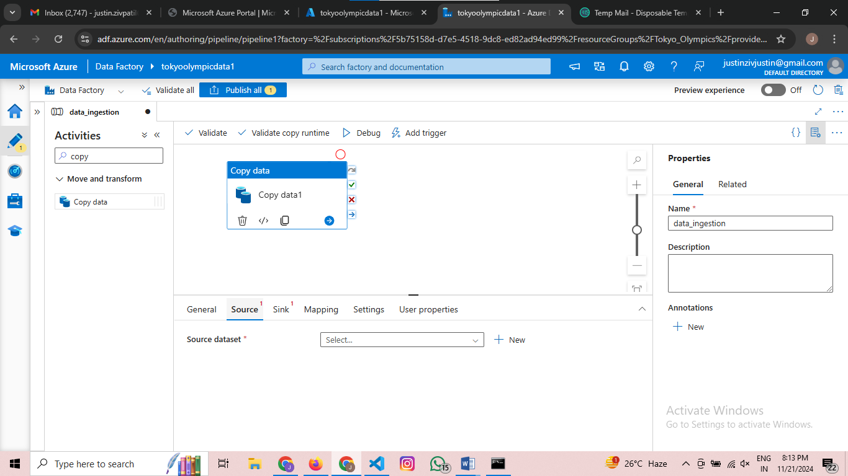

Press new then the page looks like this

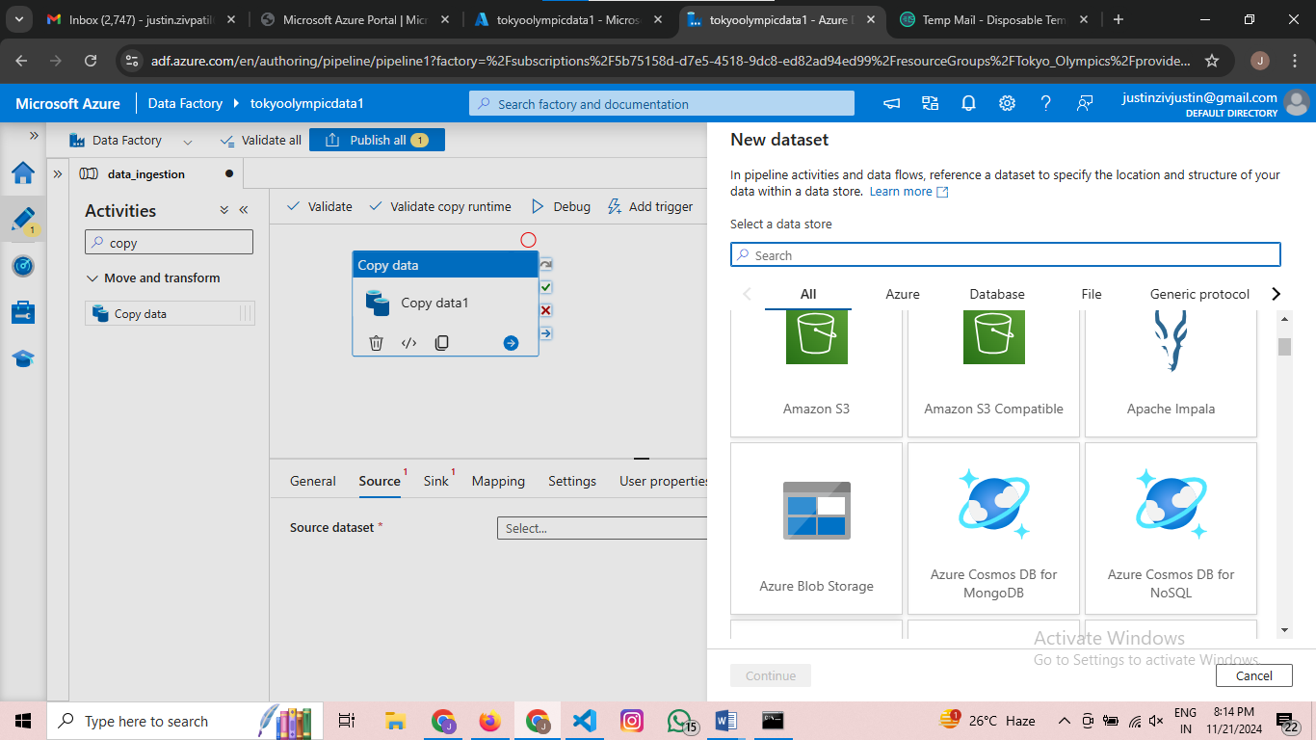

Hence we have used Azure Blob Storage select that button

Then the page looks like below

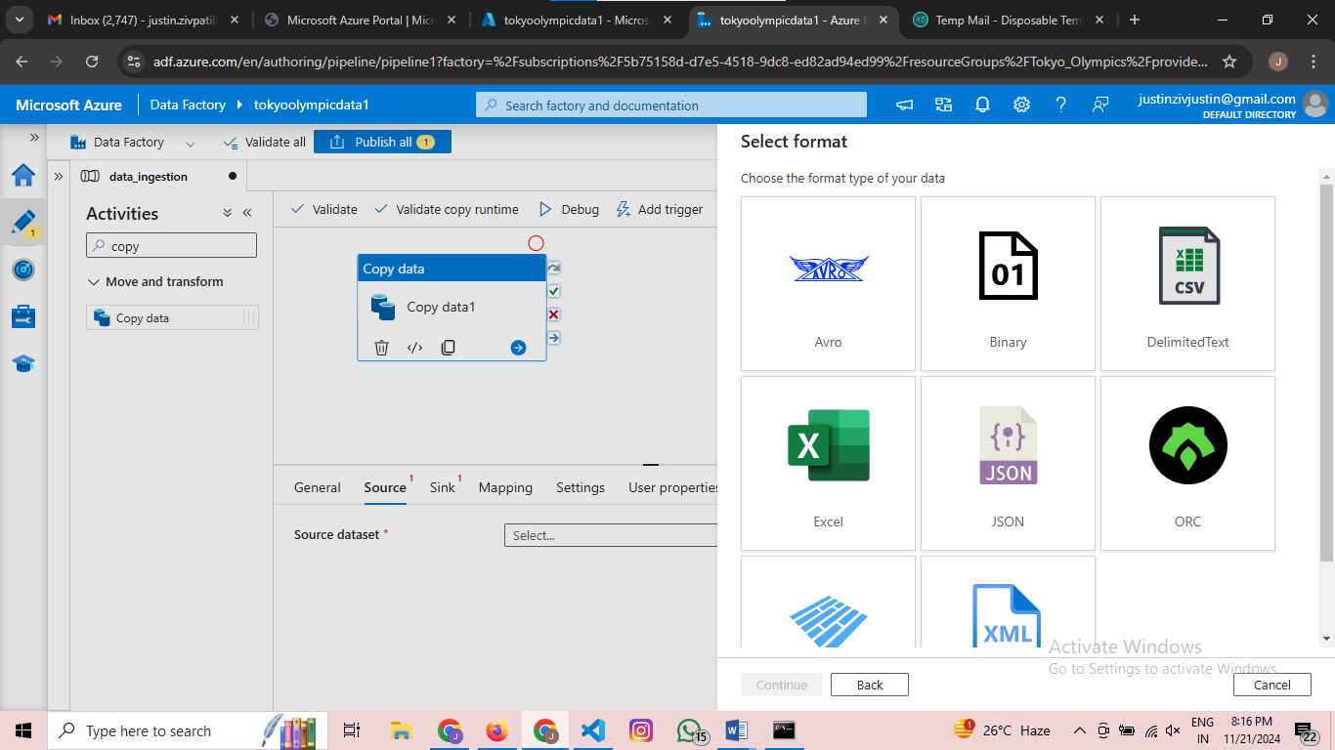

After selecting CSV file the page looks like below

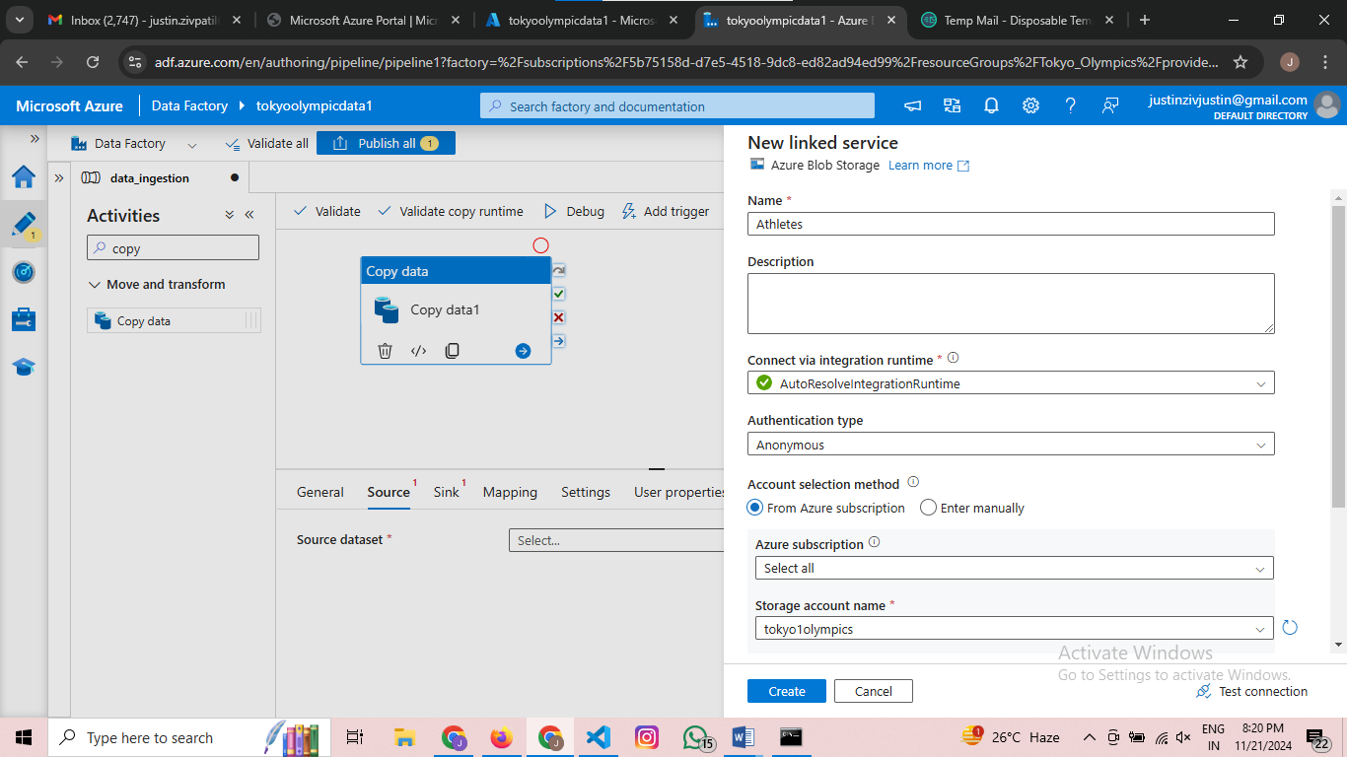

Select everything as I mentioned in the above page if u choosen diiferent name use that name in place of storage account name and Conatiner

Then press create then your page looks like this

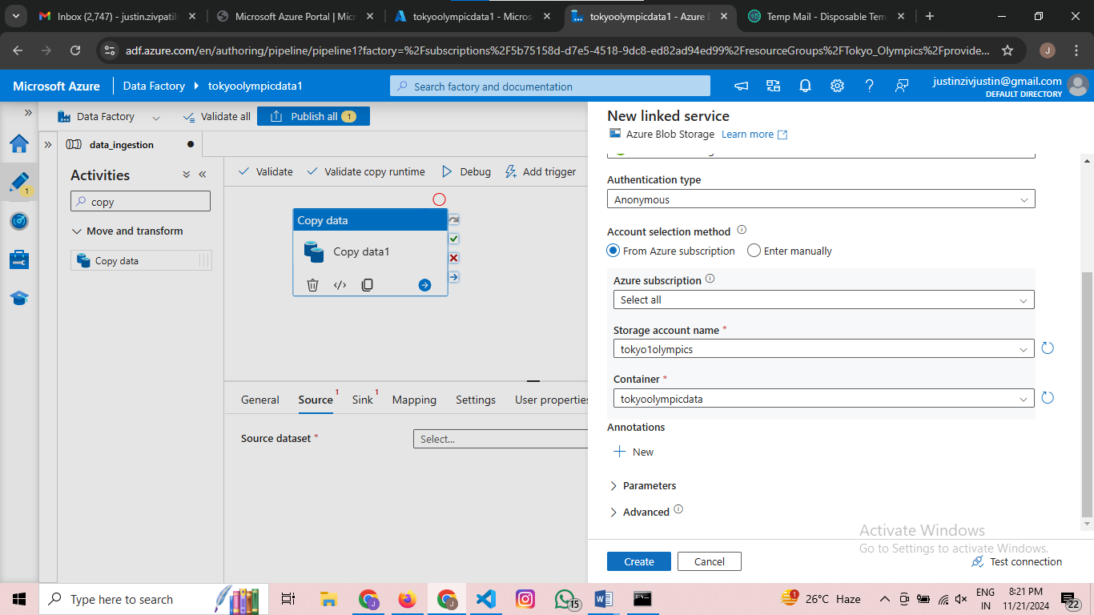

Go for search bar and search for http

Then select http as below

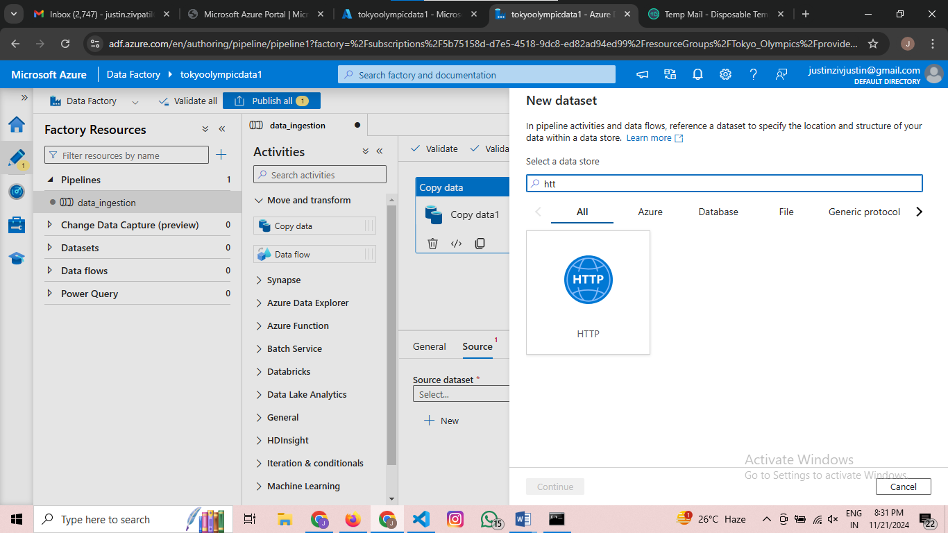

Then named the parameters as I named it

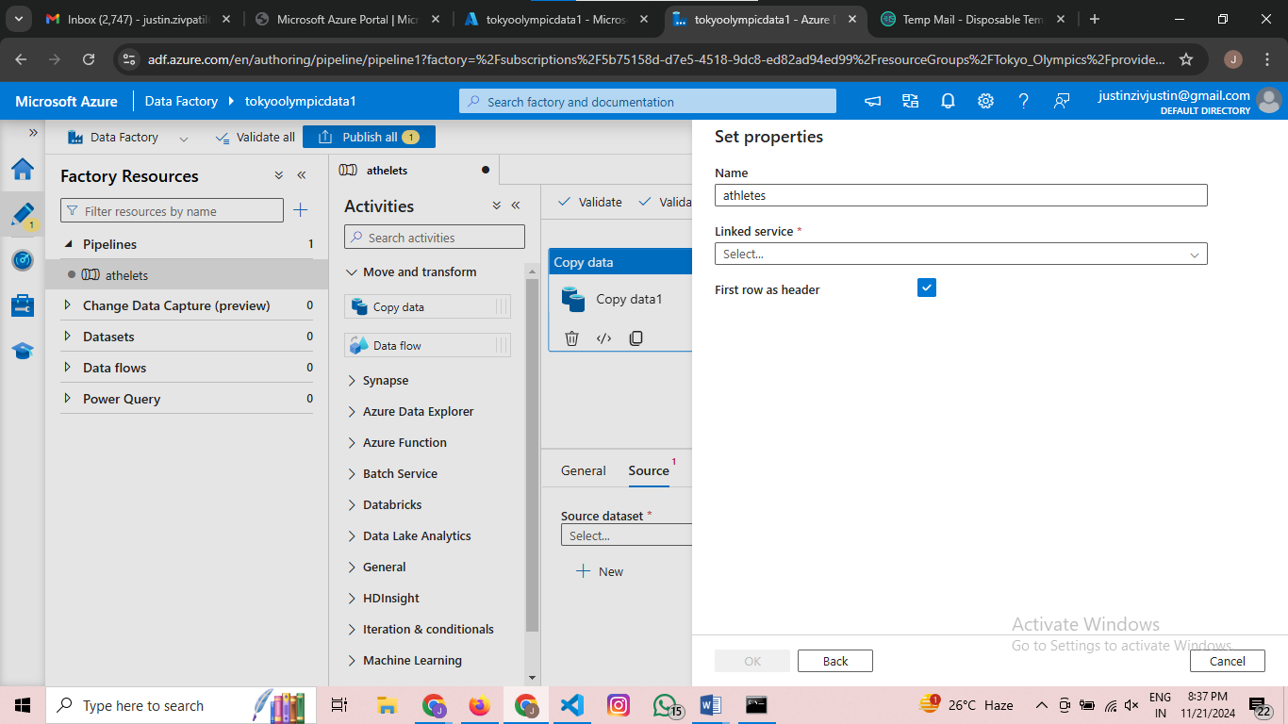

Then press on linked services-🡪 select🡪 new then page looks like this

Then go to the github link where the dataset is stored press on raw and choose copy link address and copy the link then later do as below screenshot   
Paste the link in the baseURL and choose anonymous Authenication type then press create as below

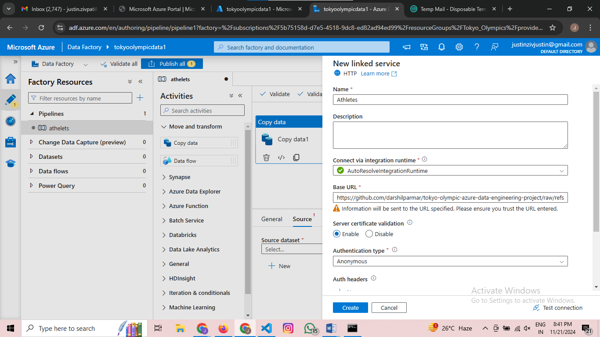

Then your pages looks like below

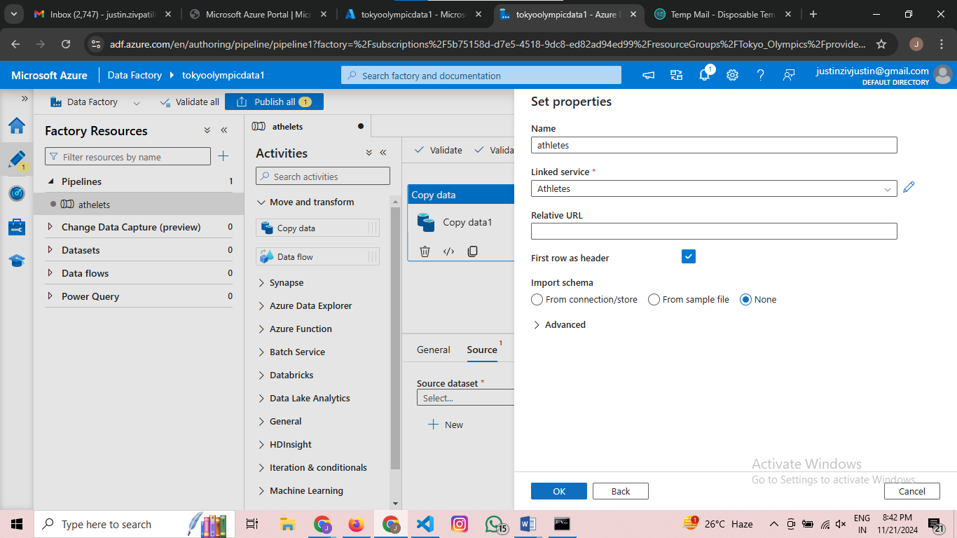

Remember to keeps first row as a headed on

After that the page looks like this

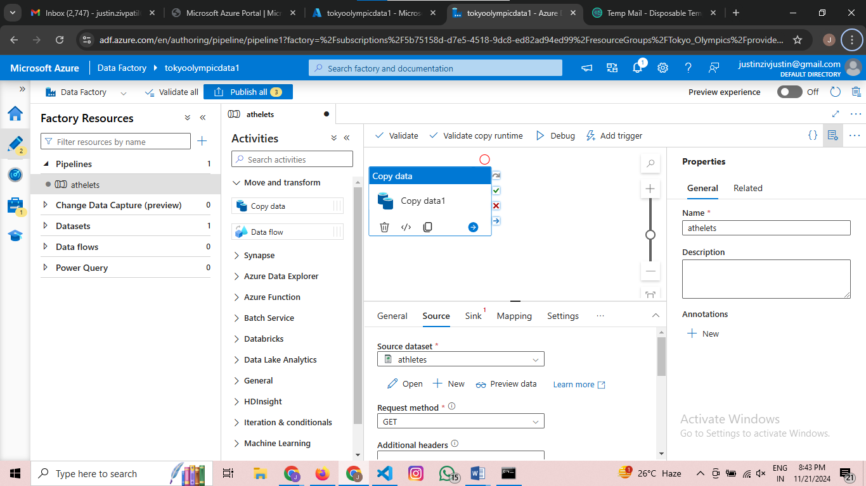

To see wether the data is imported or not we will use preview data

If its correct the actual data and the preview data will match as below

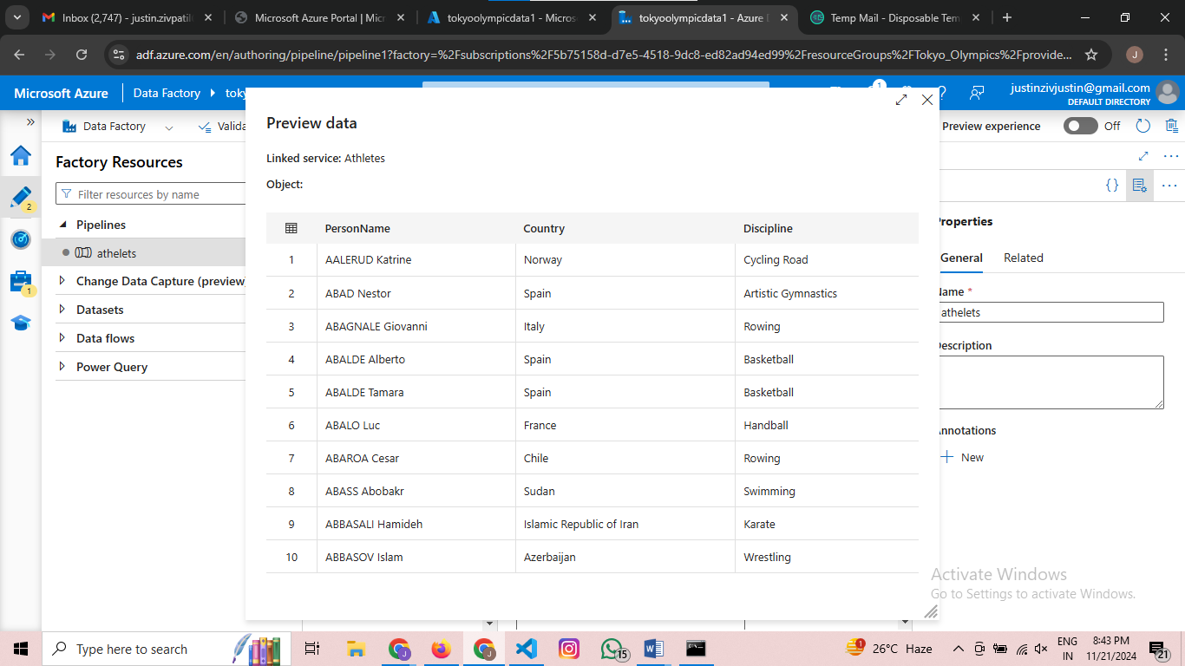

Rename the copy data as athelets for the convention

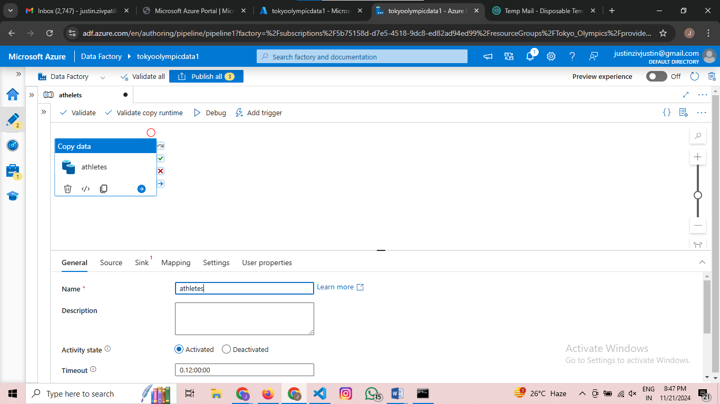

Pending……………..

Step Azure Databricks

Search for Azure Databricks

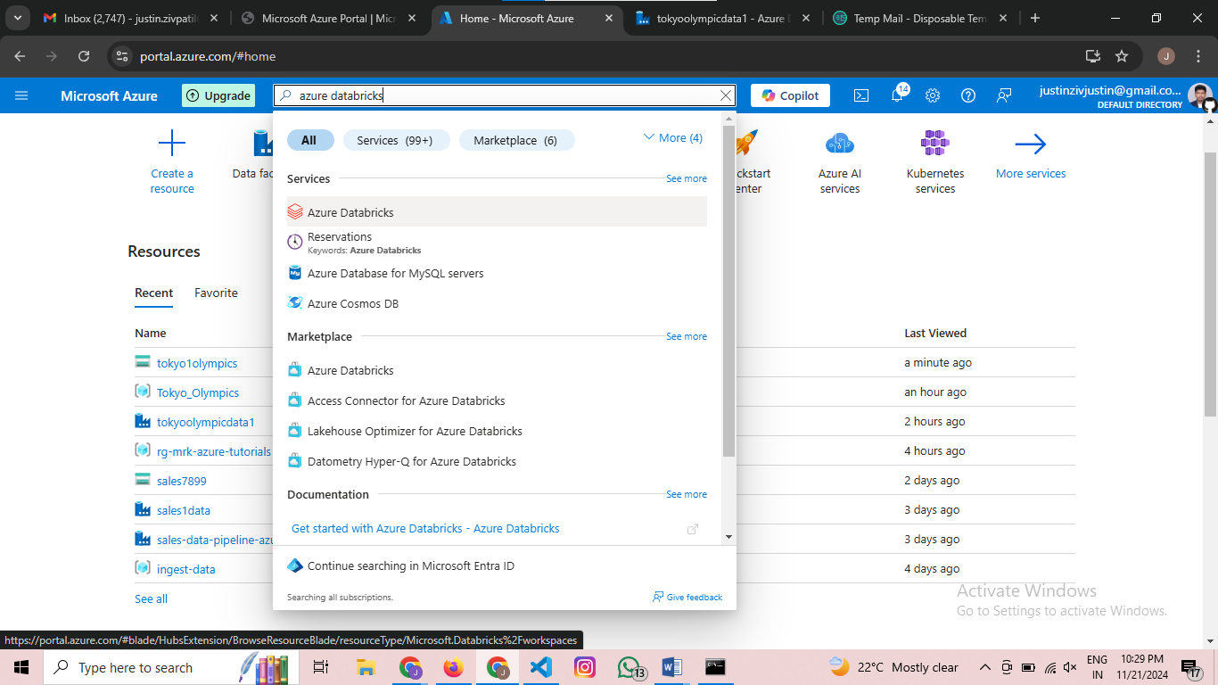

Then choose the first one

Then the page appears as below

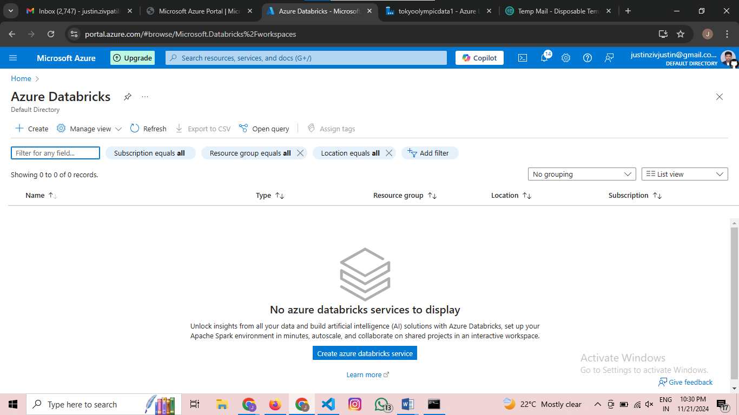

Then select the create a azure databrick services

Then the page appears like this

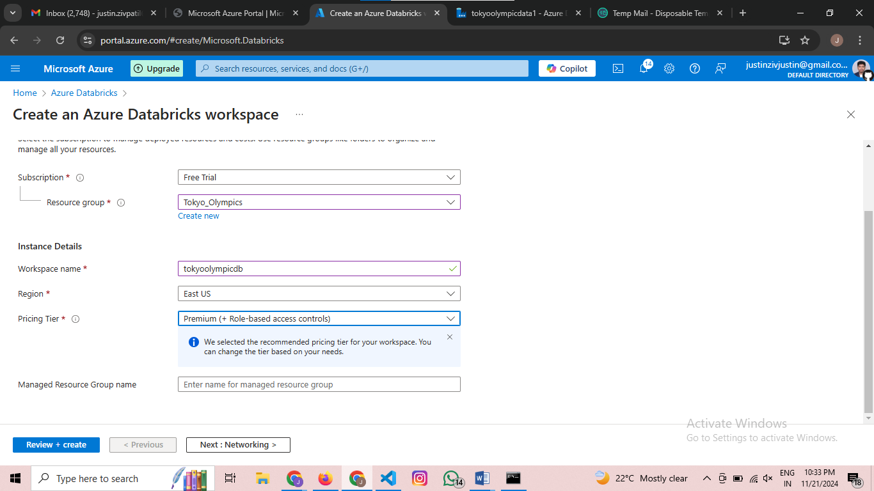Select the same as I selected and press review+create

Then after validation it looks like this

Then press create

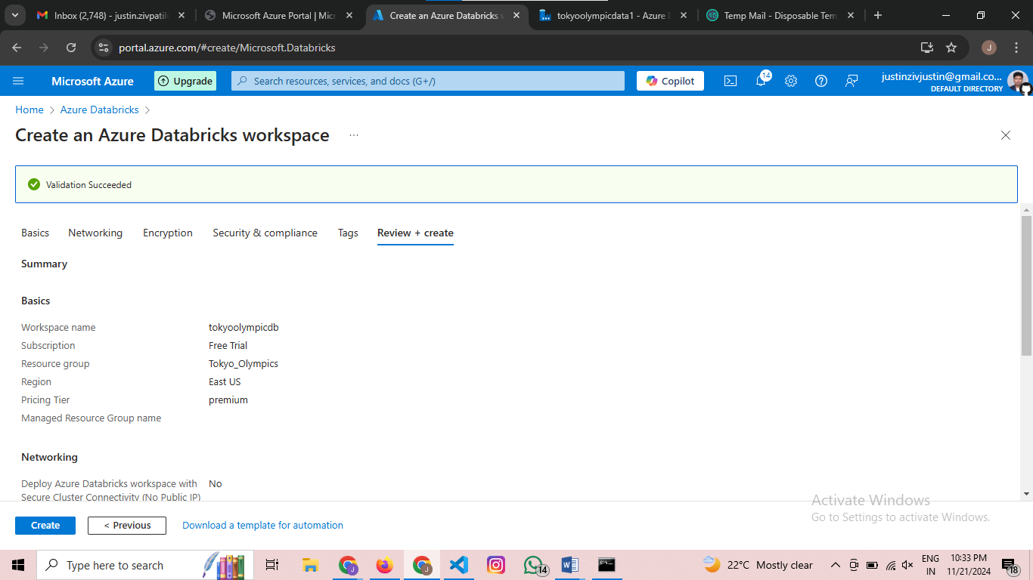

Wait for 4 to 5 mins for the deployment time then the page looks like this

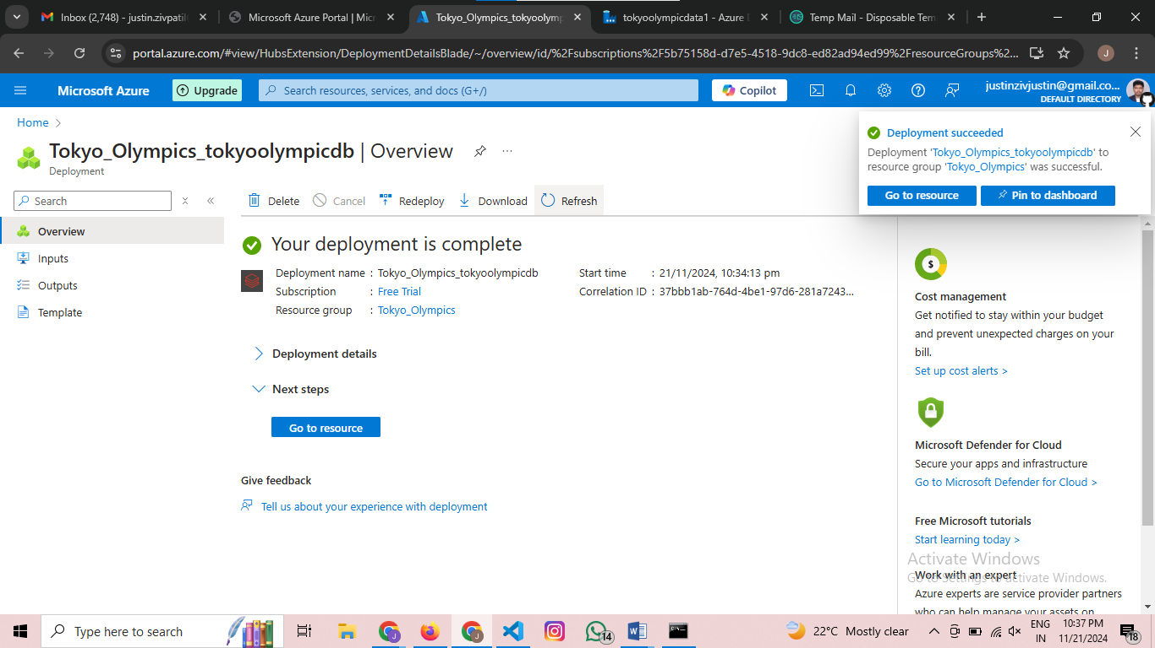

Then go to resources

The page looks like this

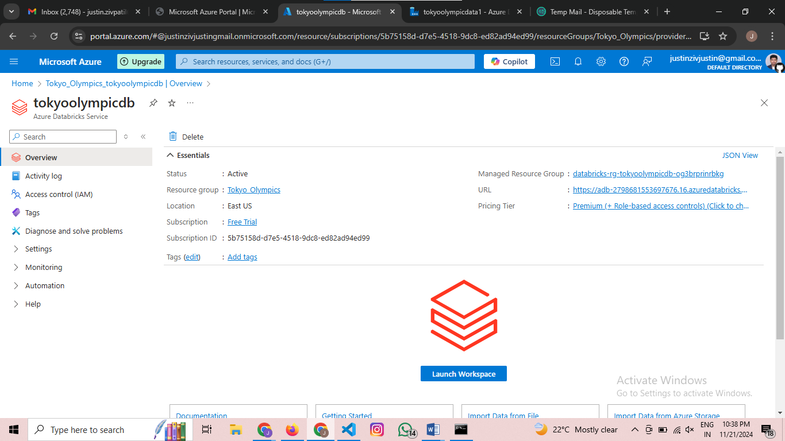

Then press Launch Workspace

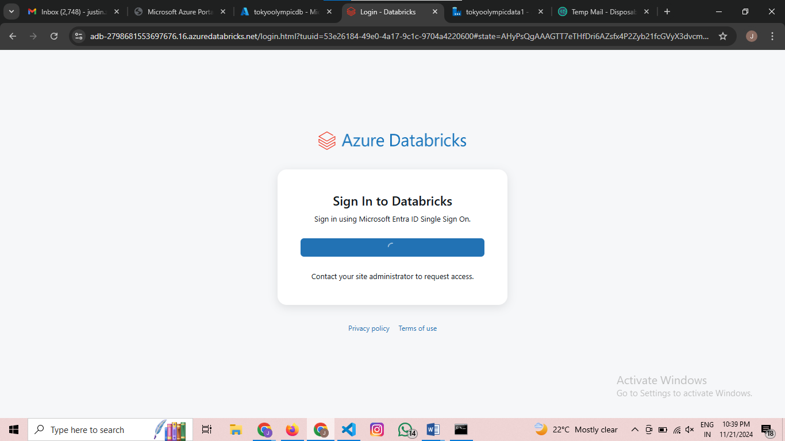

Then signin to databricks

Then your dashboard looks like this

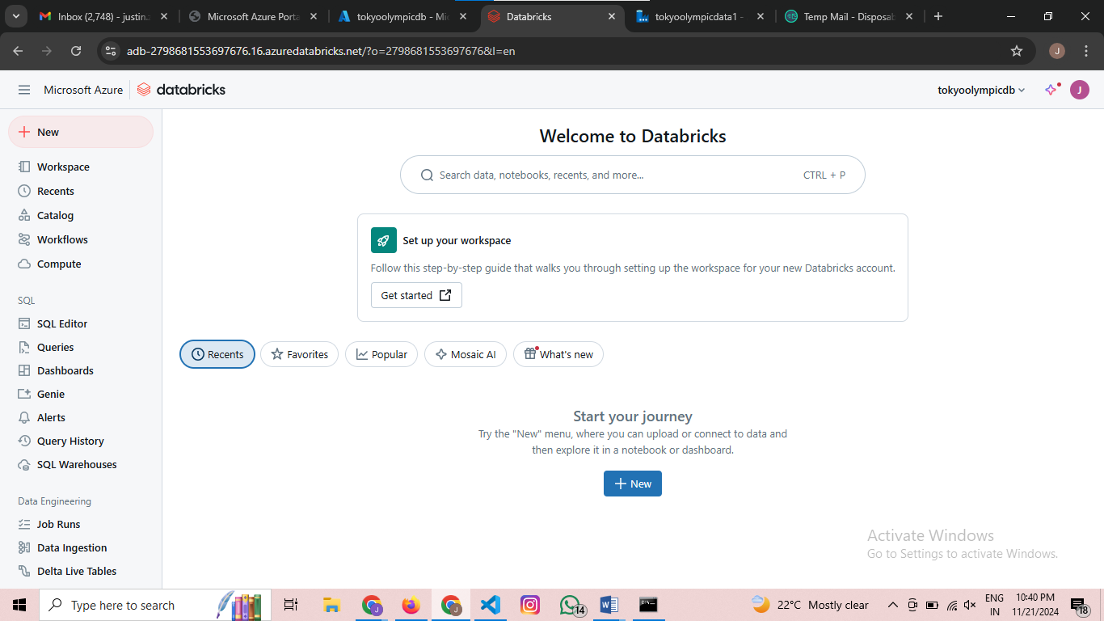

Then go to compute

Press Create Compute Then the dashboard be like as below

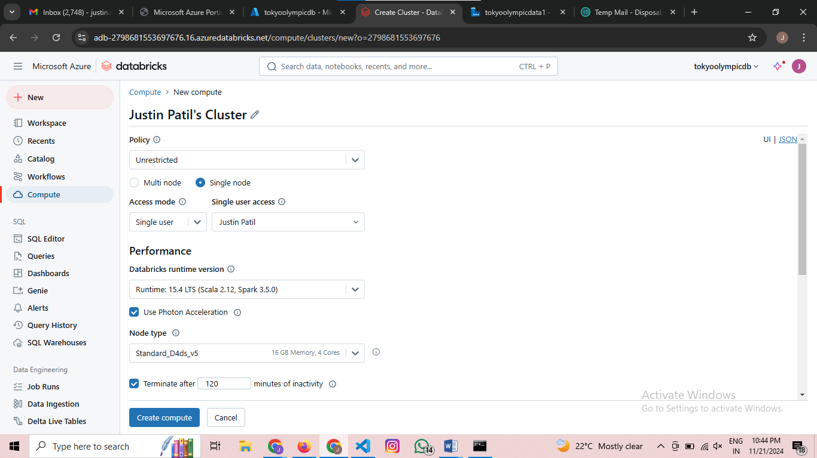

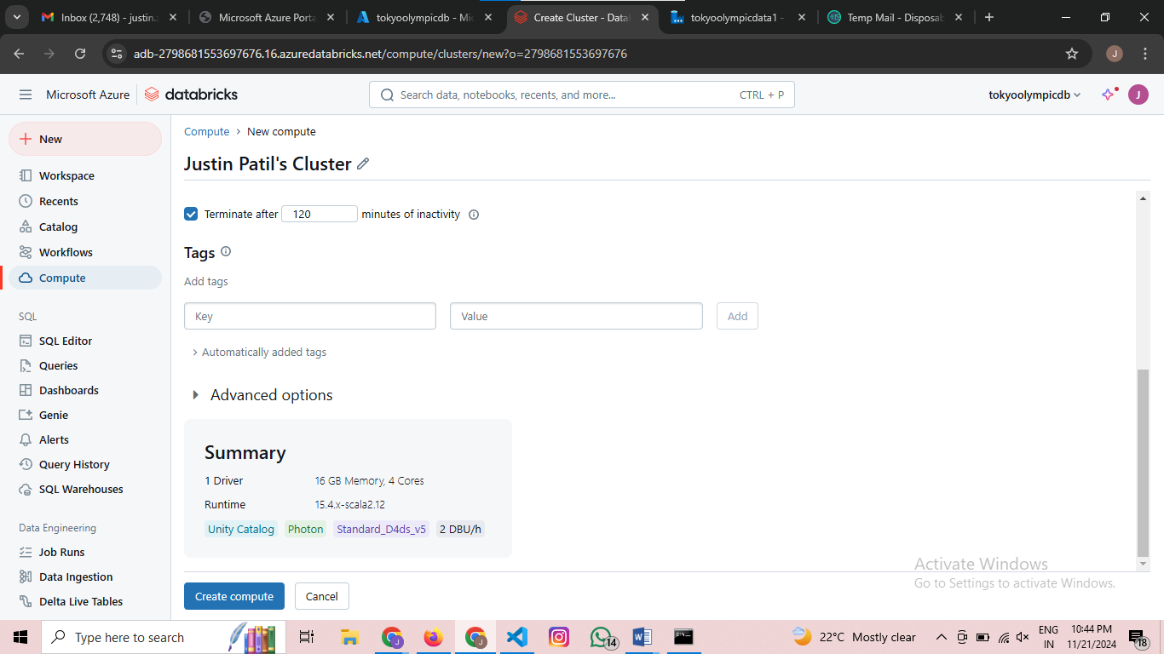

Do the changes as I selected in it

Press Create Compute it may take time wait a bit

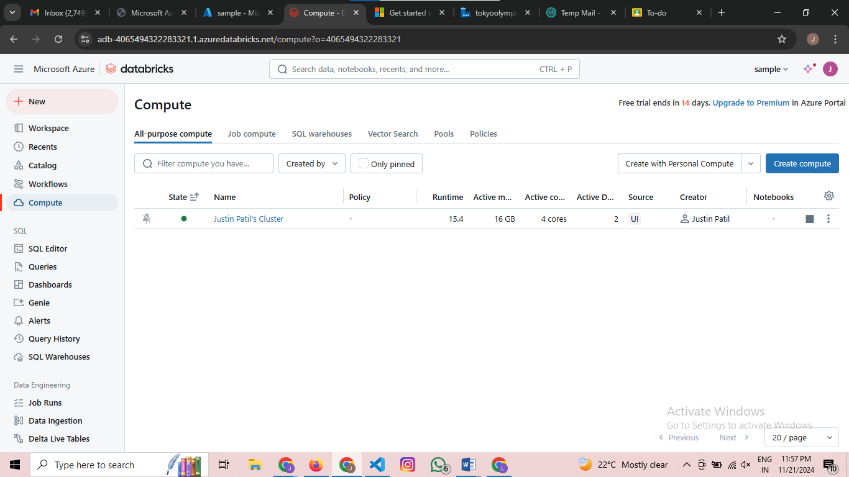

After completion of Compute

Go to new create a new notebook

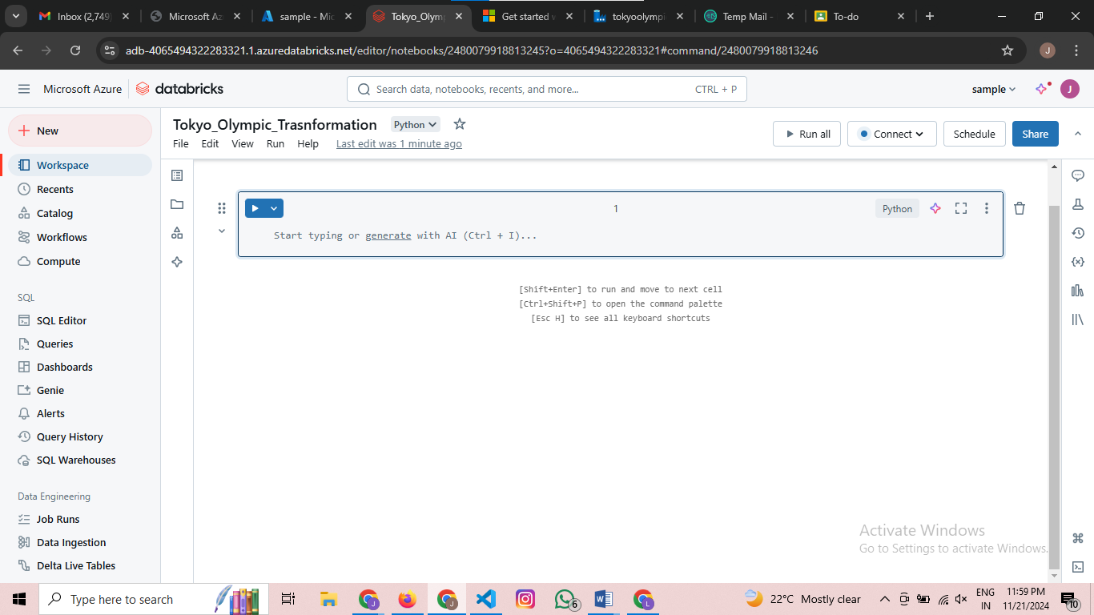

Step :- Then we have to connect an azure databrick and azure data lake storage

Attach the cluster that you have created

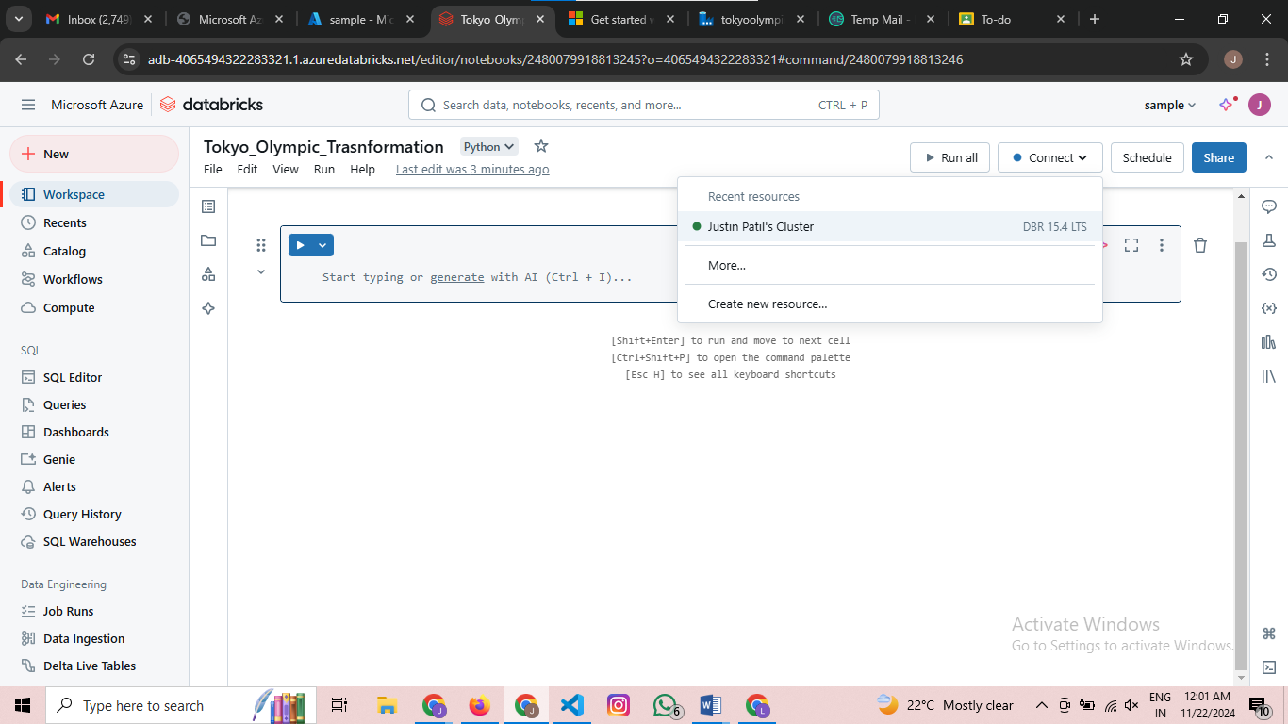

Then go to home page search for app registrations

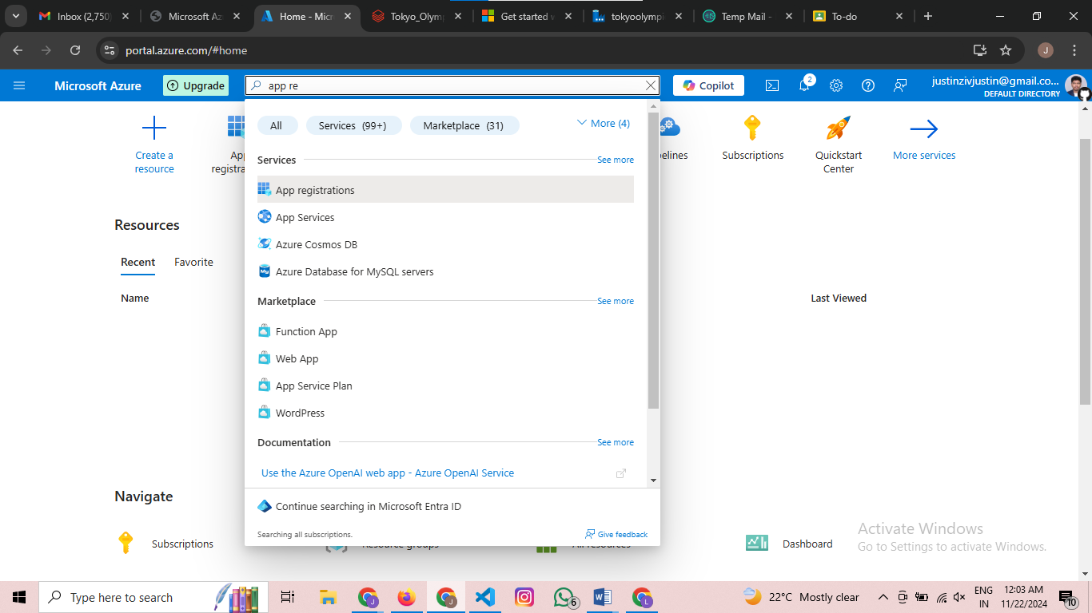

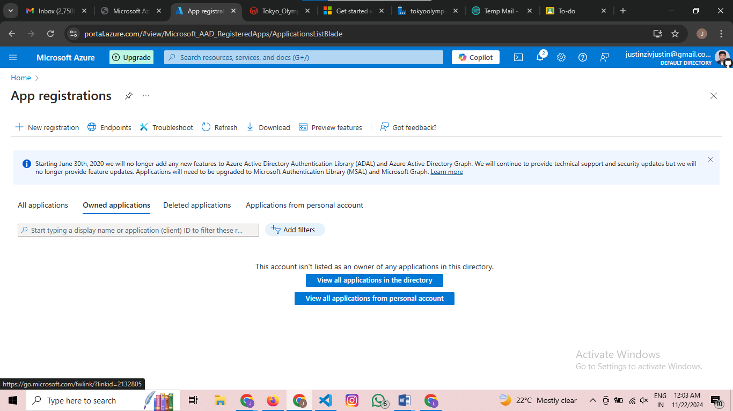

Then click on new registartions

Name the app as app01 and press register you will get a dashboard like this

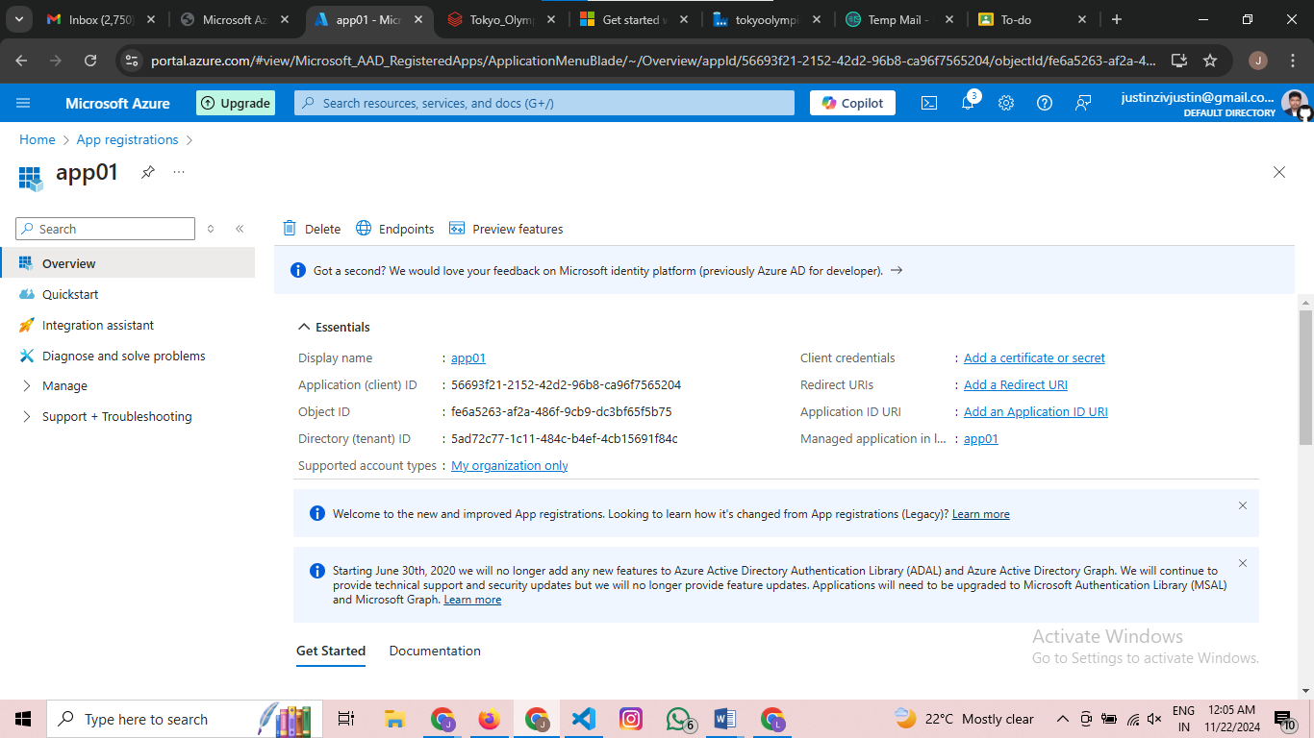

Now next procedure is to copy Application (client) ID and Directory (tenant) ID

Application (client) ID -56693f21-2152-42d2-96b8-ca96f7565204

Directory (tenant) ID- 5ad72c77-1c11-484c-b4ef-4cb15691f84c

After copying this go to manage and select certificates and secrets

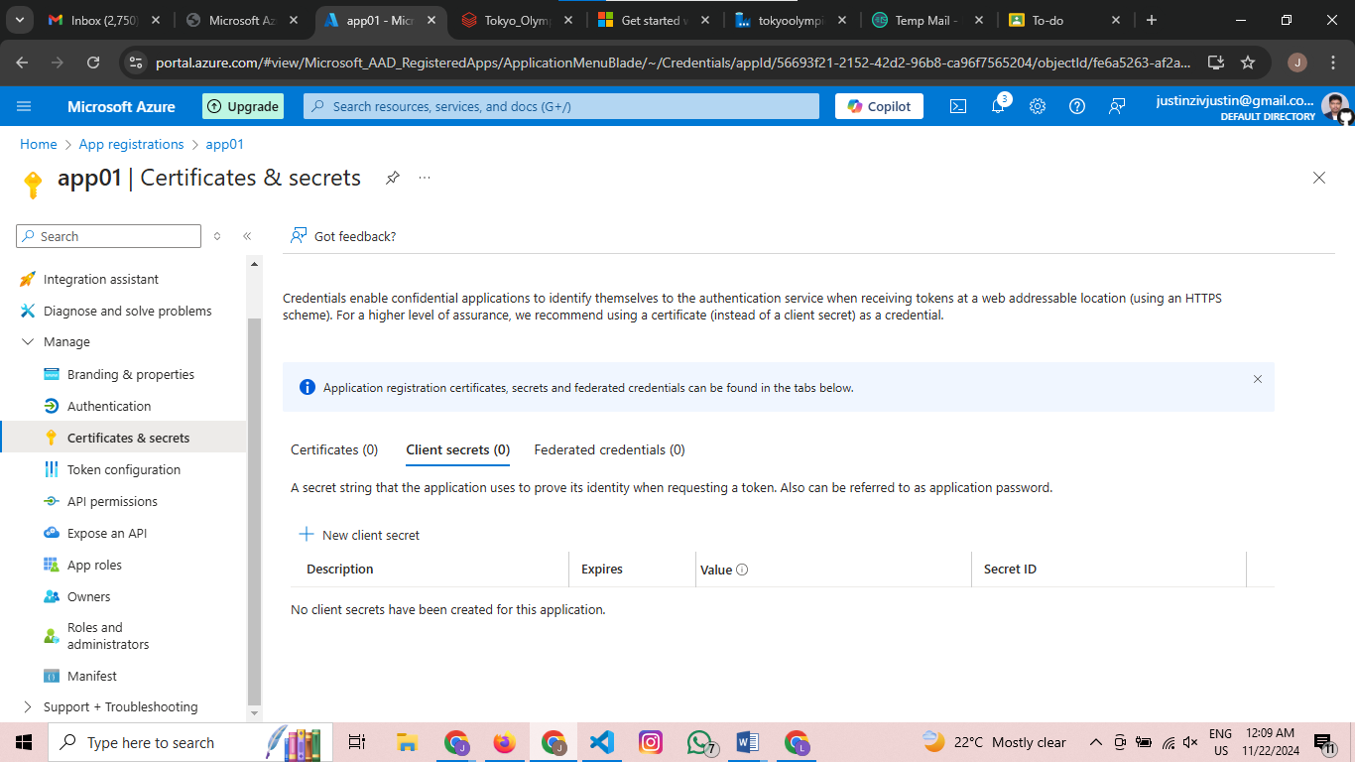

Then press on new client secret and the tab appears on the right side give a secret key of ur choice and press add 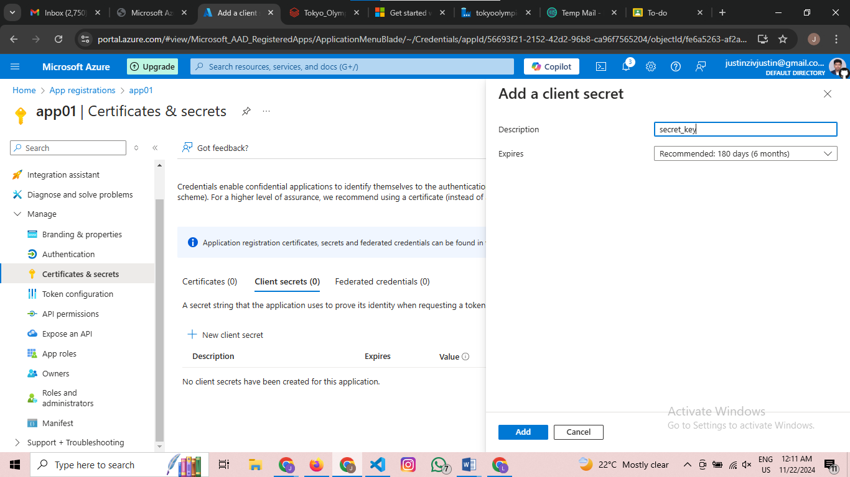

Then dashboard looks like this

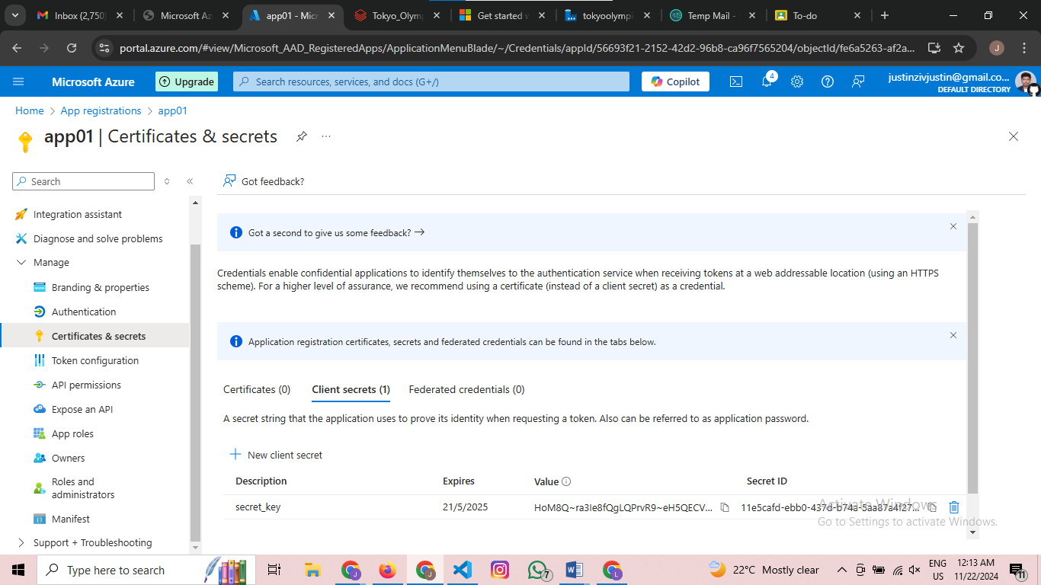

Copy the secret value and return to the Databricks again  
then paste this code In the notebook and change the client id tanent id and secret value

For mounting u have to copy the container name in this project the container name is :-

from pyspark.sql.functions import col

from pyspark.sql.types import IntegerType, DoubleType, BooleanType, DateType

configs = {"fs.azure.account.auth.type": "OAuth",

"fs.azure.account.oauth.provider.type": "org.apache.hadoop.fs.azurebfs.oauth2.ClientCredsTokenProvider",

"fs.azure.account.oauth2.client.id": "",

"fs.azure.account.oauth2.client.secret": '',

"fs.azure.account.oauth2.client.endpoint": "https://login.microsoftonline.com/tanent_id/oauth2/token"}

dbutils.fs.mount(

source = "abfss://tokyo-olympic-data@tokyoolympicdata.dfs.core.windows.net", *# contrainer@storageacc*

mount_point = "/mnt/tokyoolymic",

extra_configs = configs)

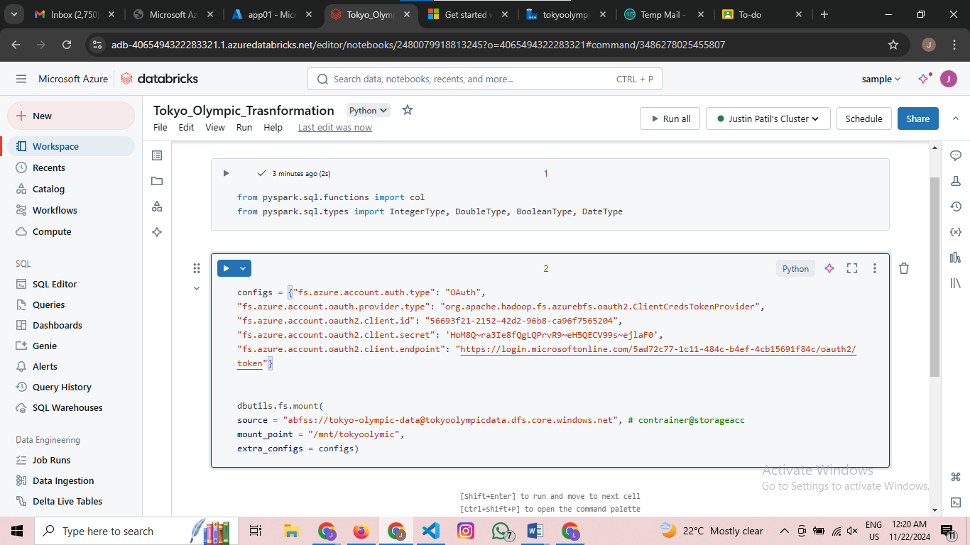

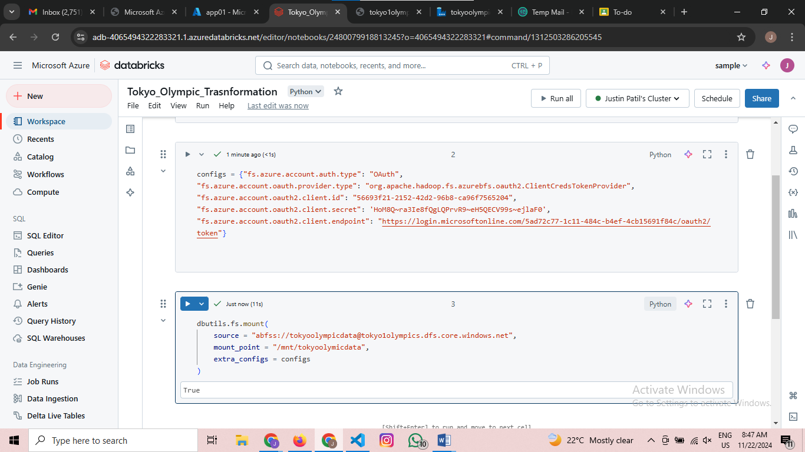

If all permissions are correct the output be as above  
Its mounted successfully

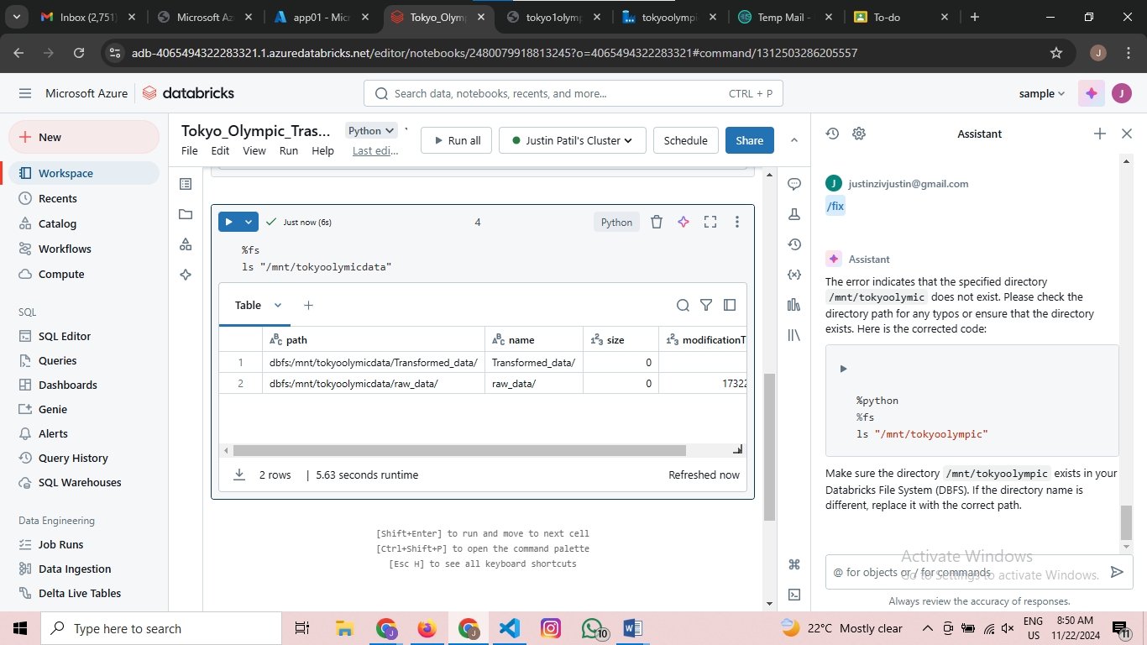

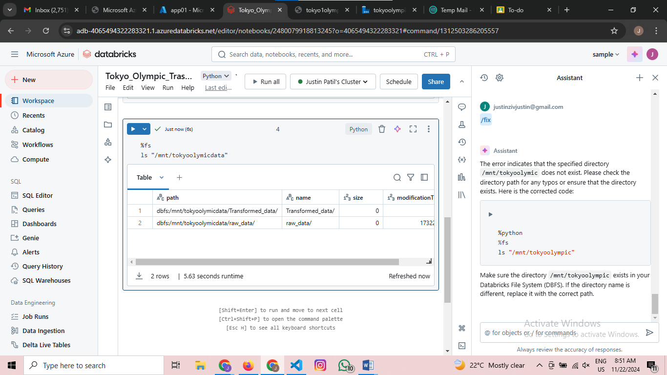

Load the data

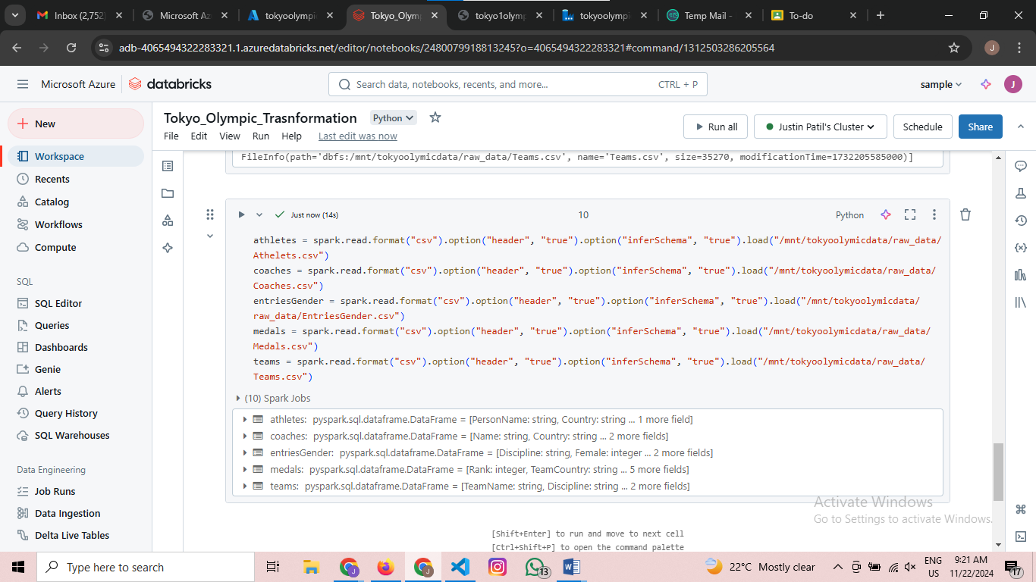

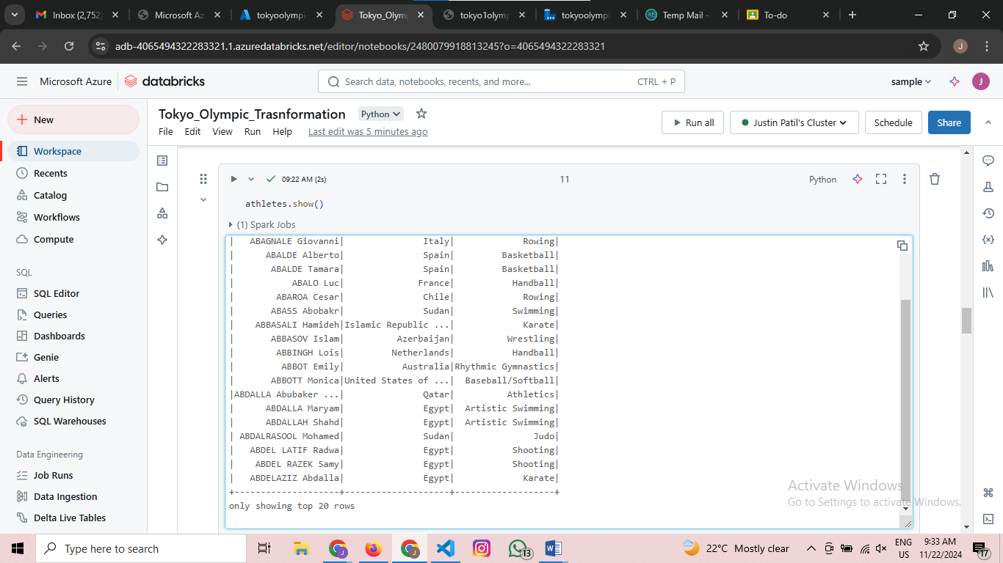  
Check wether the data is loaded properly  
Do for all the datastes and transform the data is ists necessaey

Steps :- To load the data to targeted location

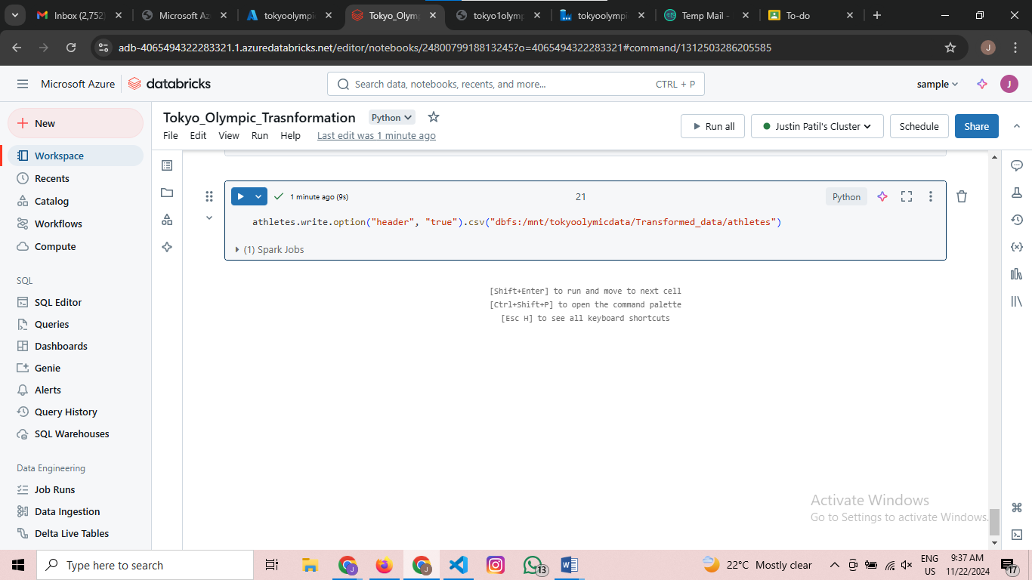

After mounting you can see the files in the transform data folder

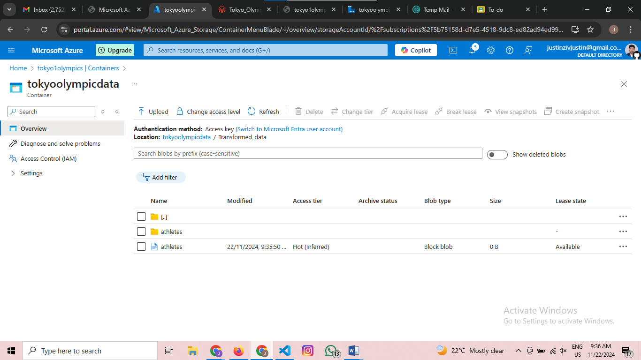

Steps :- Now Creating a synapse Analytics

Go back to azure portal and search for synapse analytics  
The dashboard looks like this

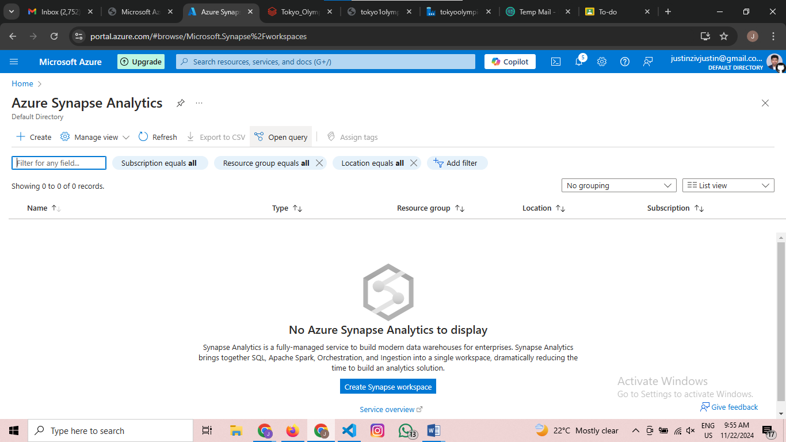

Go to Create Synapse Workspace

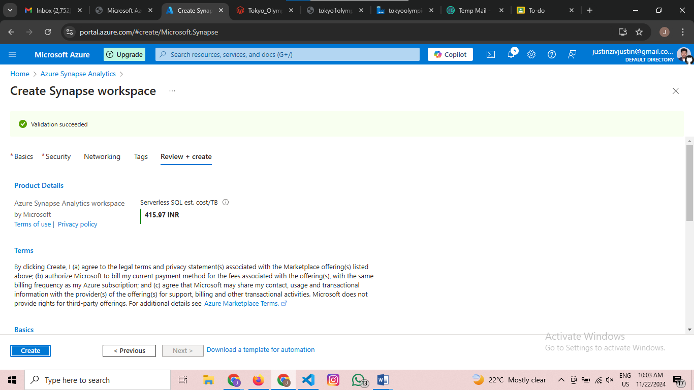

Successfully Created Synapsis Workspace

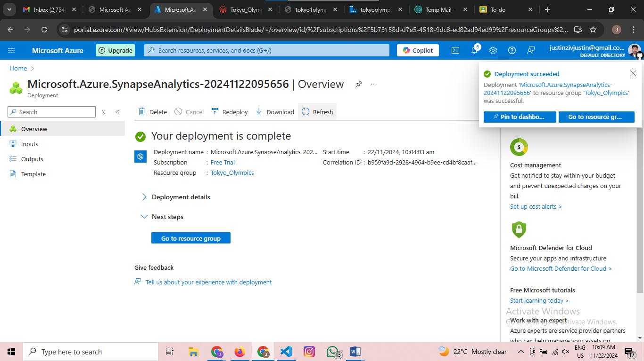

Deployed Successfully

Then go to resource group

Then the dashnoard looks like this

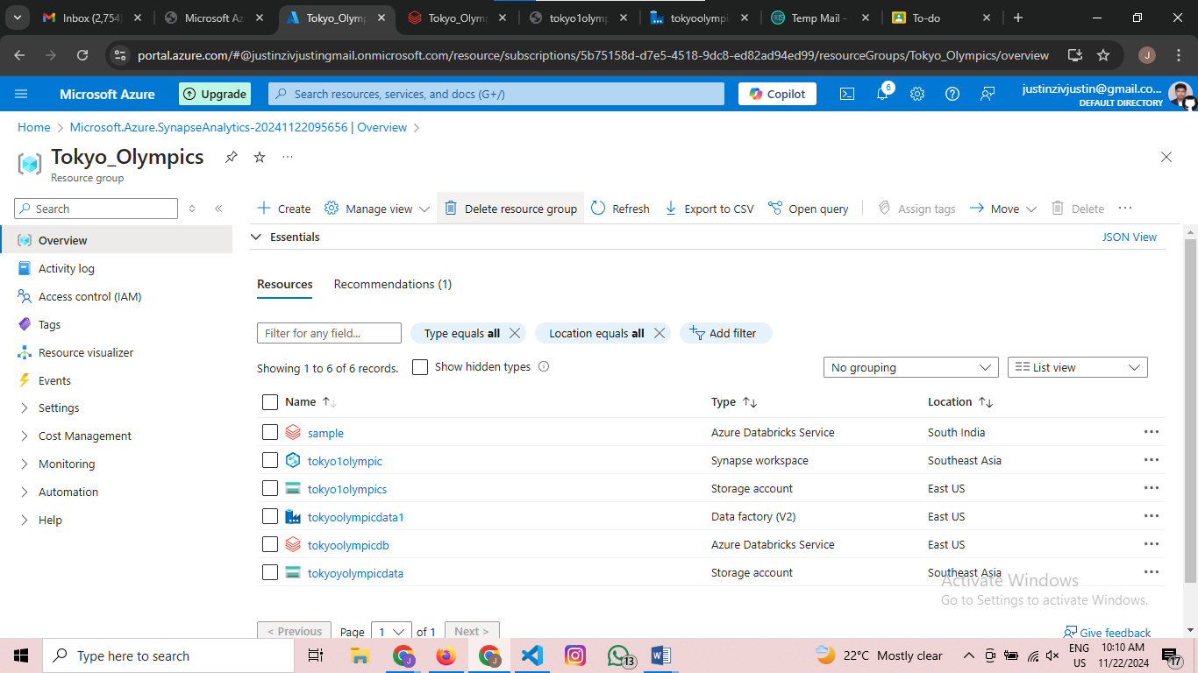

Then go to tokyoolympic synapse

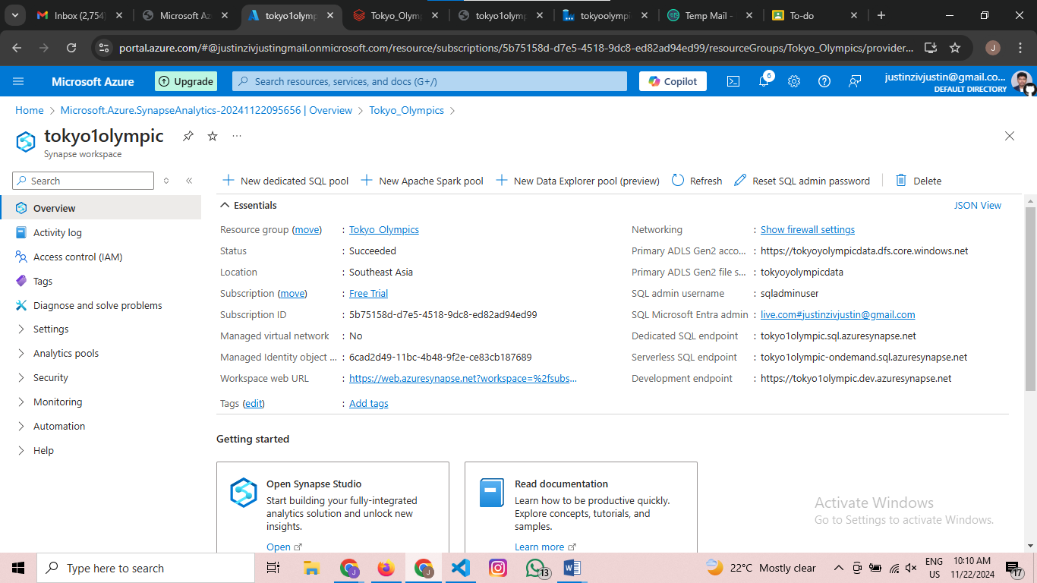

Then go to synapse studio

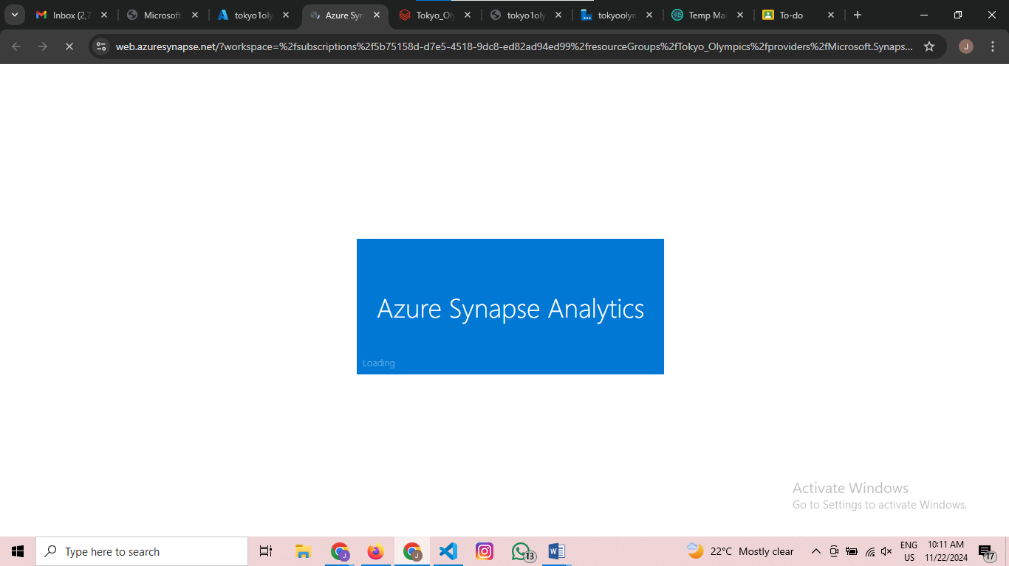

Wait for few mins

After the setup the dashboaord lookslike this

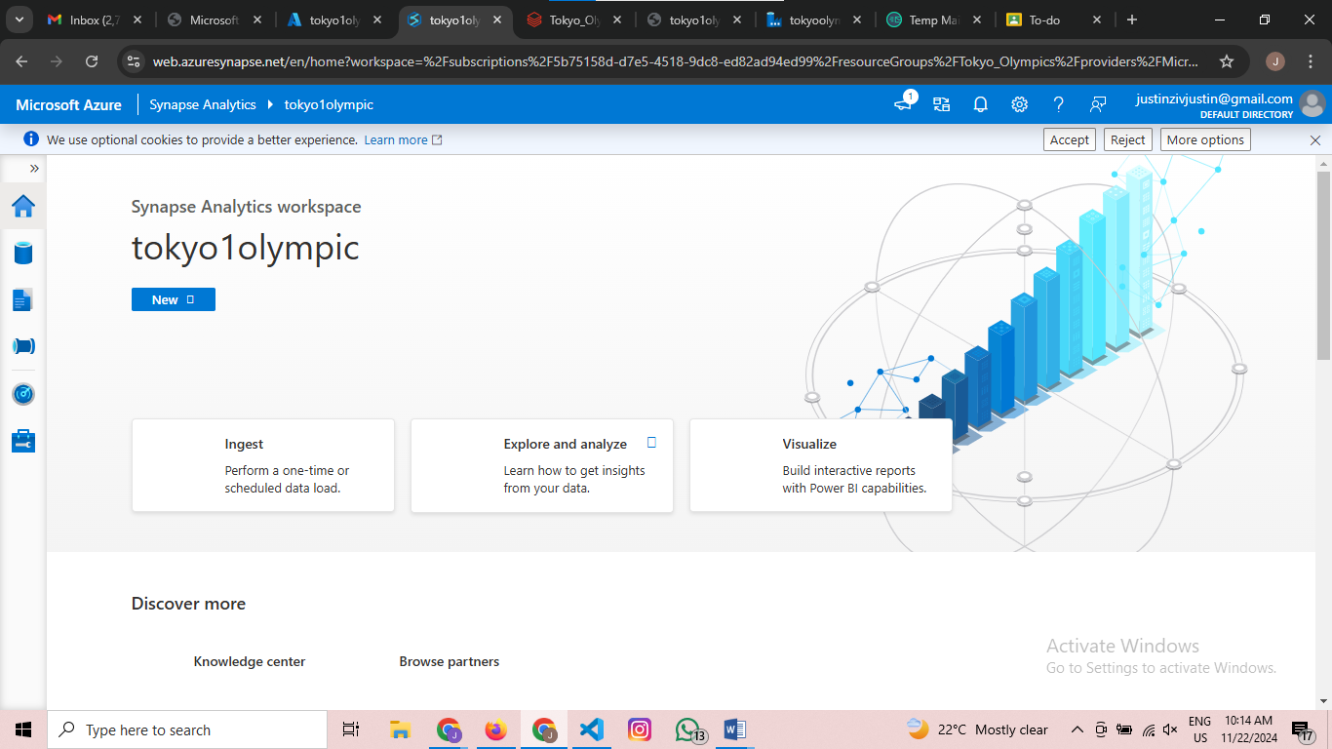

Then go to left side panel expand the menu and press on data then the dashboard looks like this

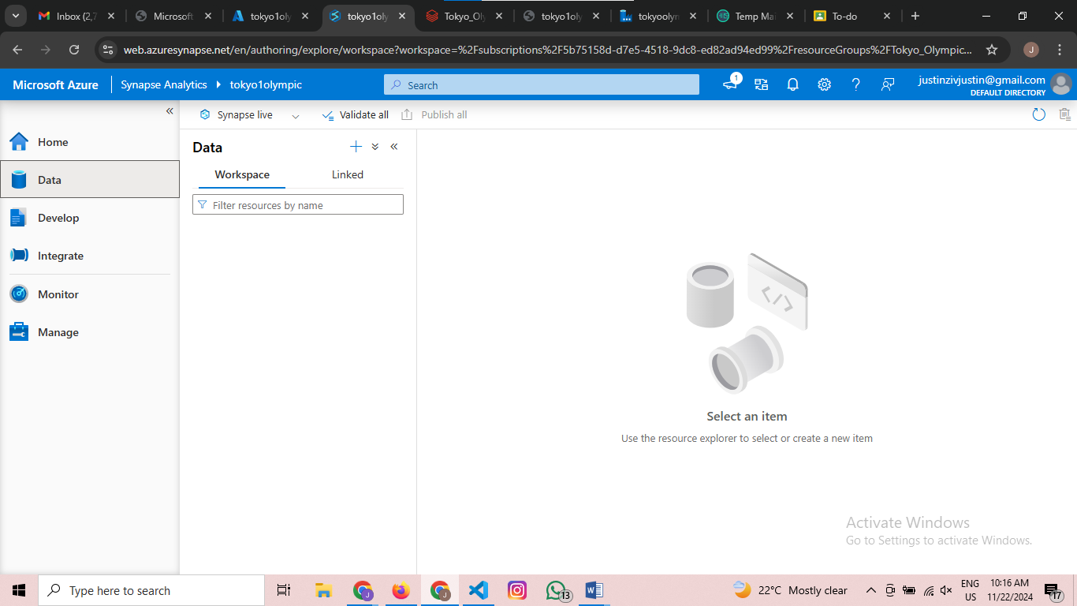

Then in here you can analyze your data using sql .